NURSERY MODERNIZATION PLAN
(Absheron Nursery)

FOREST RESOURCES ASSESSMENT AND MONITORING TO STRENGTHEN FOREST KNOWLEDGE FRAMEWORK IN AZERBAIJAN
GCP/AZE/007/GFF




FOREST RESOURCES ASSESSMENT AND MONITORING TO STRENGTHEN FOREST KNOWLEDGE FRAMEWORK IN AZERBAIJAN
GCP/AZE/007/GFF

NURSERY MODERNIZATION PLAN
(Absheron Nursery)

Prepared by
Mr. Ahmet Yalvaç, Dr. Çağlar Başsüllü, and Mr. Rahim Ibrahimov

Baku, February 2020

Content

Content i
Abbreviations ii
Executive Summary iii
1. Introduction 1
1.1. Objectives of the Nursery Modernization Plan 3
1.2. Structure of the Nursery Modernization Plan (How to Use Nursery Modernization Plan).. 3
1.3. Target Groups 4
2. State of Absheron Nursery (Gaps and Needs) 4
3. Nursery Modernization Plan 7
3.1. Technical Planning Considerations (Design and Layout) 8
3.2. Detailed List of Items (Goods, works and other services) under Project Budget 21
3.3. Detailed List of Items (Goods, works and other services) under Municipataly and MENR Budget 27
3.4. Investment Plan under Project Budget 28
3.5. Investment Plan under Municipataly Budget 28
3.6. Investment Plan under MENR Budget 28
4. Recommendations for Trainings 29
5. Workplan 29
6. Proposal for Upscaling at the National Level 29
References 33
Annex: Technical Specifications 34

Abbreviations

cc Cubic centimeter
cm Centimeter
cm³ Cubic centimeter
CPF Country Programming Framework
FAO Food and Agriculture Organization of the United Nations
g Gram
GDF General Directorate of Forestry in Turkey
GEF Global Environmental Facility
Ha Hectare
hp Horse power
INDCs Intended Nationally Determined Contributions
Kg Kilogram
km Kilometer
kW Kilowatt
m Meter
mg Miligram
mm Milimeter
m² Square meter
m³ Cubic meter
MENR Ministry of Ecology and Natural Resources
REDD+ Reducing Emissions from Deforestation and Forest Degradation in Developing Countries; and the Role of Conservation, Sustainable Management of Forests and Enhancement of Forest Carbon Stocks in Developing Countries
SDGs Sustainable Development Goals
SFM Sustainable Forest Management
SLM Sustainable Land Management
UNCBD The United Nations Convention on Biological Diversity
UNFCCC The United Nations Framework Convention on Climate Change
UNFF The United Nations Forum on Forests
USD United States Dollar

Executive Summary

Forest ecosystems in Azerbaijan represent great potential in terms of production of goods and services, which emphasized the importance of human well-being and the environment. Azerbaijan’s rich forests are currently managed for protection purposes only, yet they represent a vast untapped potential in terms of production, including in terms of carbon sequestration. Moreover, there are vast areas of land in Azerbaijan that currently have little or no forest cover yet are suitable for forestry. If brought under sustainable forest management, this could make a major contribution to the local economy as well as in carbon sequestration.

Sustainable forest management and rehabilitation/restoration of degraded forests and other lands would support the existing activities to reverse the current situation of degradation and help switch forestry onto a path of increased forest cover, increased social and economic benefits from forests, increased goods and services and an improved quality of existing forests.

Sustainable forest management practices, rehabilitation/restoration techniques for degraded forests, production of ornamental seedlings and fruit tree seedlings require good quality planting materials. These planting materials can be produced in well-structured, organized, established and managed nurseries.

A nursery is a managed site that is established to produce good quality planting materials grown under special conditions and care to be used for planting for sustainable forest management practices, rehabilitation/restoration of degraded forests and horticulture.

Nursery Modernization Plan was prepared under Food and Agriculture Organization of the United Nations (FAO)/Global Environmental Facility (GEF) funded Forest Resources Assessment and Monitoring to Strengthen Forest Knowledge Framework in Azerbaijan (GCP/AZE/007/GFF) project. The main objectives of the Plan are to provide guidance on the modernization of Absheron Nursery and to create suitable conditions for large-scale rehabilitation and restoration of degraded forest areas. The Nursery Modernization Plan will support the Ministry of Ecology and Natural Resources (MENR) by providing necessary information on technical planning considerations and investment costs for the modernization of Absheron Nursery.

Nursery Modernization Plan targets nursery workers and nursery supervisors, forestry practitioners and policy and decision-makers from the MENR. The Nursery Modernization Plan also targets the State and private nursery managers and administrators, horticulturists, seedling producers and natural resource managers from respective agencies.

Nursery Modernization Plan consists of seven broad sections. Introduction section provides brief information about the importance and establishment purposes of nurseries and their role in global forest and other lands restoration needs, objectives, content, and structure of the Nursery Modernization Plan including target groups. The section on State of Absheron Nursery provides analyses and information on the current state of the nursery and defines the gaps and needs. The main section of the Nursery Modernization Plan clearly set the roadmap for the modernization of the Absheron Nursery. This includes technical planning considerations and investment plans. The section on List of Items describes the necessary goods, works and other services for modernization activities. Recommendations section defines the necessary training needs for staff and workers. Work Plan section sets the required period for the modernization of Absheron Nursery, tender process, and organization of pieces of trainings. Finally, Section on Proposal for Upscaling at National Level describes the options for maintenance and upscaling the use of Nursery Modernization Plan at the national level through establishing a nursery network.

The Nursery Modernization Plan will be a supporting tool for the modernization of Absheron Nursery, which will target the production of plant materials for rehabilitation/restoration, sustainable forest management and horticulture (i.e. fruit and nut trees, medicinal plants, ornamental plants). Absheron Nursery will be able to produce 1,200,000 seedlings per year and will provide an employment opportunity for 14-15 government staff and 35 rural women and men.

Introduction

Forest ecosystems in Azerbaijan represent great potential in terms of the production of goods and services, which are important for human well-being and the conservation of the environment. Moreover, vast areas of land in Azerbaijan have little or no forest cover yet are suitable for forestry. If brought under sustainable forest management (SFM) these areas could contribute to the production of goods and services as well as local livelihoods and protection of nature. In addition to these lands, some of the existing forests are currently being degraded due to overgrazing, unsustainable use of resources, etc. Degraded forestlands should also be restored/rehabilitated to improve the production capacity of these resources and enhance the contributions to livelihoods and economy.

SFM, rehabilitation/restoration of degraded forests and horticulture practices could remove the barriers in Azerbaijan to reverse the current situation of degradation and help switch forestry onto a path of increased forest cover, increased social and economic benefits from forests including improved livelihoods, increased goods and services and an improved quality of existing forests.

SFM practices, rehabilitation/restoration techniques, and horticulture practices require good quality planting materials. These planting materials can be produced in well-structured, organized, established and managed nurseries.

A nursery is a managed site that is established to produce good quality planting materials grown under specific conditions to be used for planting for SFM practices, rehabilitation/restoration of degraded forests and other lands and horticulture practices.

Nurseries play a critical role in global efforts to combat climate change, forest degradation, land degradation, desertification, and support forest and landscape restoration programmes. This is ensured by providing high-quality seedlings for restoration/rehabilitation of degraded forests and other lands, supporting forest management practices and establishment of new forest ecosystems and supplying seedlings for fruit and nut trees including medicinal and aromatic plants.

The recognition of the social, economic and ecological contributions of forest ecosystems and the global environmental benefits, which are provided through restoration/rehabilitation of degraded forests and other lands, and the ongoing international negotiations on climate change, land degradation, desertification, and biodiversity conservation, resulted in commitments by countries to restore/rehabilitate millions of hectares of deforested and degraded lands.

For example, 150 million hectares of deforested and degraded land around the world by 2020 and 350 million hectares by 2030 were targeted by using a landscape approach under the Bonn Challenge. Reducing Emissions from Deforestation and Forest Degradation in Developing Countries; and the Role of Conservation, Sustainable Management of Forests and Enhancement of Forest Carbon Stocks in Developing Countries (REDD+) aims to reduce emissions from deforestation and forest degradation in developing countries. Parties committed to promote sustainable management and promote and cooperate in the conservation and enhancement, as appropriate, of sinks and reservoirs of all greenhouse gases not controlled by the Montreal Protocol, including biomass, forests, and oceans as well as other terrestrial, coastal and marine ecosystems under the United Nations Framework Convention on Climate Change (UNFCCC). A similar approach to stop forest loss and conserve forests and many more targets were also adopted through Intended Nationally Determined Contributions (INDCs) under Paris Agreement and global objectives on forests, United Nations Forest Instrument and United Nations Strategic Plan for Forests under United Nations Forum on Forests (UNFF). Finally, Sustainable Development Goals (SDGs) aim to protect, restore and promote sustainable use of terrestrial ecosystems, sustainably manage forests, combat desertification, and halt and reverse land degradation and halt biodiversity loss. Nurseries could help to meet these commitments by providing high-quality seedlings.

Nurseries can also serve as a seed bank, provide storage for species, establish and maintain demo plots, seed orchards, stooling beds, and other sources of propagative material. In addition to that, nurseries can be used as training centers and educational programs can be implemented in nurseries including extension services. Nurseries also provide an enabling environment for research activities to improve the seedling production and harvesting techniques and seedling quality as well. Moreover, nurseries play a key role for the improvement of livelihoods of people through providing employment to nursery workers (Haase and Davis, 2017).

Absheron Nursery is old and mostly out of the latest technology and produces seedlings under outdated techniques. Absheron Nursery should be modernized for the planning and implementation of restoration/rehabilitation of degraded forests and other lands, support SFM, reforestation, erosion control activities and horticulture practices. The aforementioned activities require high-quality seedlings in order to achieve the expected goals.

Nursery Modernization Plan recognizes the importance of nurseries as an essential part of forestry activities. Therefore, the Nursery Modernization Plan is in line with the FAO Country Programming Framework (CPF), project document, project implementation strategy, and MENR expectations.

Nursery Modernization Plan was prepared to provide guidance for the modernization of Absheron Nursery. Nursery Modernization Plan will support the MENR by providing necessary information technical planning considerations and investment costs for the modernization of Absheron Nursery. A draft design and layout plan that demonstrates the location of facilities and seedling production areas was also provided within the Nursery Modernization Plan.

Modernization will enable Absheron Nursery to provide high-quality seedlings for large-scale restoration/rehabilitation of degraded forests and other lands in the country, reforestation, erosion control, prevention of soil loss; and for riverside plantation activities. Moreover, Absheron Nursery will produce seedlings of fruit and nut trees including medicinal and aromatic species and ornamental plants to support public and private sector demands. High-quality seedlings will play a critical role to create healthy and resilient forest ecosystems and other landscapes. In the long-term, Absheron Nursery will serve to meet the objectives of MENR and contribute to the livelihoods of local communities through employment and production of income-generating species.

Absheron Nursery will be able to produce 1,200,000 seedlings per year and will provide an employment opportunity for 14-15 government staff and 35 rural women and men.

It should be noted that Absheron Nursery should be supported with trained and experienced staff, modern facilities and technologies, machinery, tools and equipment, assistance of stakeholders, cooperation between relevant agencies, law enforcement, and most importantly consistent and constant budget allocation and incentives for the sustainability purposes (Haase and Davis, 2017).

Objectives of the Nursery Modernization Plan

Nursery Modernization Plan (the Plan hereinafter) was prepared to provide guidance on modernization of Absheron Nursery.

The objectives of the Nursery Modernization Plan are to:

- Provide guidance on the modernization of Absheron Nursery,
- Strengthen the understanding of the importance and establishment purposes of nurseries and their role in global forest and other lands restoration/rehabilitation needs,
- Support the MENR by providing necessary information on technical planning considerations and investment costs for modernization of Absheron Nursery,
- Define training needs for key stakeholders (managers, technical staff, etc.) for capacity building and improved expertise.

The Plan will be a supporting tool for the modernization of Absheron Nursery, which will target the production of plant materials for rehabilitation/restoration, sustainable forest management and horticulture (i.e. fruit and nut trees, medicinal plants and ornamental plants) in Azerbaijan.

Structure of the Nursery Modernization Plan (How to Use Nursery Modernization Plan)

Nursery Modernization Plan consists of six broad sections. Introduction section provides brief information about the importance and establishment purposes of nurseries and their role in global forest and other lands restoration needs, objectives, content, and structure of the Nursery Modernization Plan including target groups. The section on State of Absheron Nursery provides analyses and information on the current state of the nursery and defines the gaps and needs. The main section of the Nursery Modernization Plan clearly set the roadmap for the modernization of the Absheron Nursery. This includes technical planning considerations and investment plans. The section on List of Items describes the necessary goods, works and other services for modernization activities. Recommendations section defines the necessary training needs for staff and workers. Work Plan section sets the required period for the modernization of Absheron Nursery, tender process, and organization of piece of trainings. Finally, Section on Proposal for Upscaling at National Level describes the options for maintenance and upscaling the use of Nursery Modernization Plan at the national level through establishing a nursery network.

Target Groups

The Concept Proposal targets nursery workers and nursery supervisors, forestry practitioners and policy and decision-makers from the MENR. The Plan also targets the State and private nursery managers and administrators, horticulturists, seedling producers and natural resource managers from respective agencies.

State of Absheron Nursery (Gaps and Needs)

Absheron Nursery is located close to Ceyranbatan town (around 3.7 km distance) along the Gumyatag Lake. The distance from Baku to Ceyranbatan is around 18-20 km. Figure 1 provides the location of Absheron Nursery. The road from Ceyranbatan to Absheron needs to be stabilized or even asphalt road would be needed. This work should be done by the municipataly.

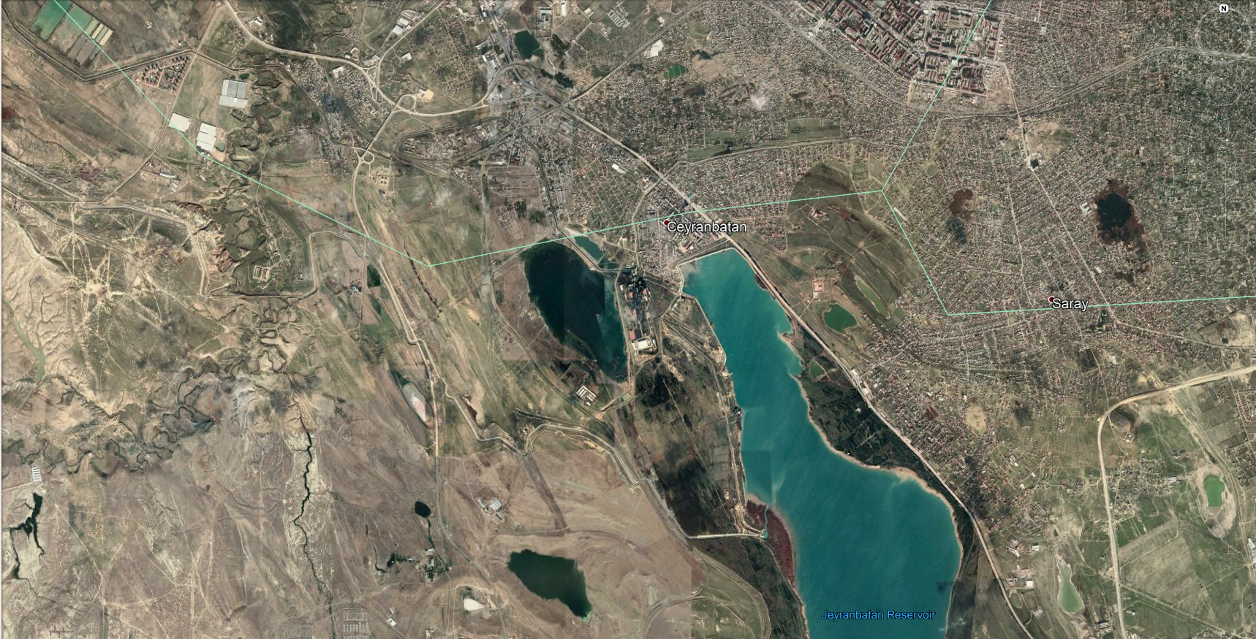
Figure 1. Absheron Nursery
The total area of Absheron Nursery Unit is 72 ha. The land belongs to Absheron Nursery Unit. As of now, only 14 ha of area is used for seedling production. List of species is given in Table 1.

Table 1. List of species
1 | Pinus eldarica | 13 | Prunus domestica
2 | Cupressus sempervirens | 14 | Amygdalus communis
3 | Thuja orientalis | 15 | Ligustrum vulgaris
4 | Armeniaca vulqaris | 16 | Maclura aurantica
5 | Fiqus carica | 17 | Gleditia triaconthos
6 | Ulmus parvifolia | 18 | Persica vulgaris
7 | Punica granatum domestica | 19 | Morus alba
8 | Olea europaea | 20 | Diospyros lotus
9 | Fraxinus exselsior | 21 | Cerasus avium
10 | Prunus domestica | 22 | Cerasus austera
11 | Cydonia oblango | 23 | Ziziphus
12 | Elaeagnus angustifolia | 24 | Robina pseudoacacia

Plant production is done under outdated techniques and technologies. Some of the existing problems in Absheron Nursery are:

- Use of workforce instead of mechanization in nursery operations,
- Lack of modern machinery, tools, and equipment,
- Lack of adequate infrastructure, facilities, and buildings,
- Lack of modern irrigation systems,
- Limited knowledge on modern seedling production techniques,
- Use of non-standard seedling beds,
- The low production number of qualified seedlings,
- Lack of site protection,
- Limited container seedling production.

Electricity, irrigation water, gas, internet, and communication is available throughout the year.

Office building, open shelter area, guard office are old and damaged, and working conditions are not sufficient for effective working. The working area of the staff needs to be improved immediately with a new office building, new closed shelter area including office equipment such are tables, chairs, computers, heating systems, a gas pipeline for greenhouse, electricity lines, etc. Moreover, the nursery should be protected with fences. Restoration/renovation of the office building, shelter area and guard building including procurement of necessary furniture, establishment of workers facility, a gas pipeline for greenhouse, electricity lines and vehicles could be partly covered by MENR as a co-finance activity. Photographs are presented below to have a clearer picture on the current state of the nursery.
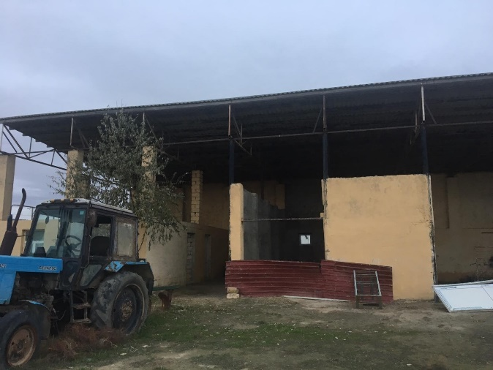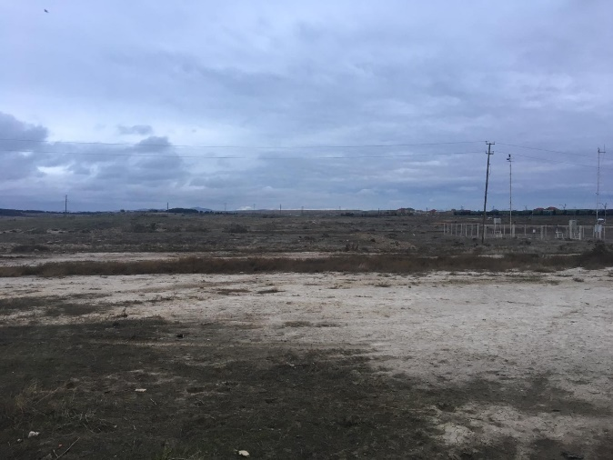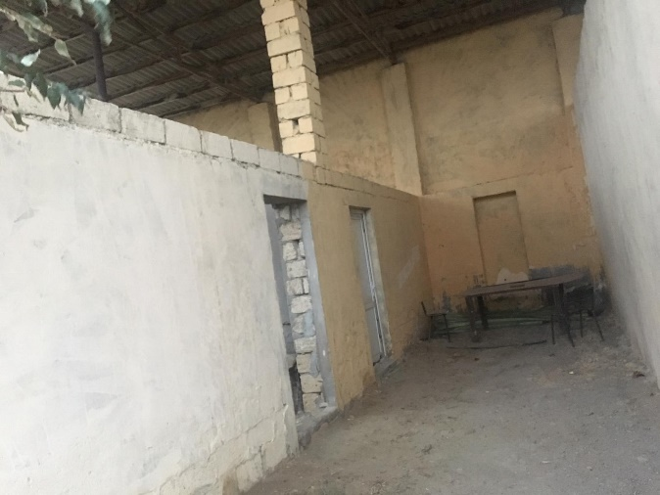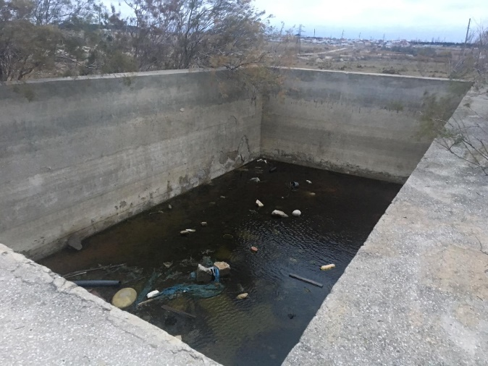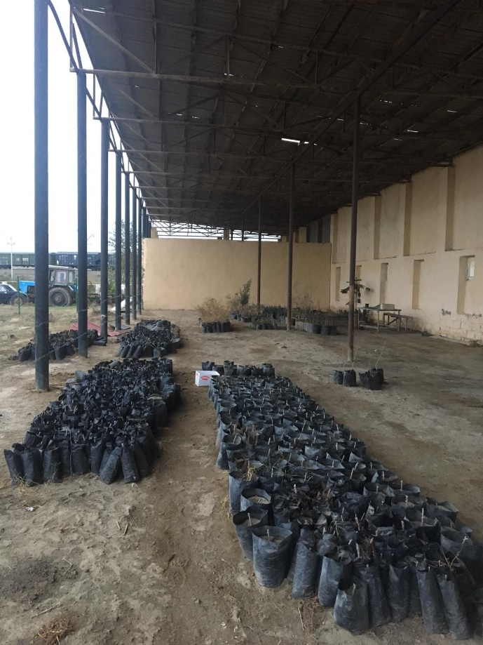
Figure 2. Current state of Absheron Nursery (Photo by Mr. Ahmet Yalvaç)
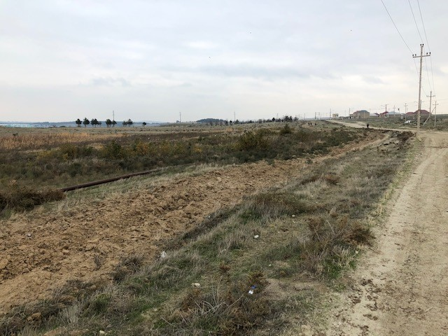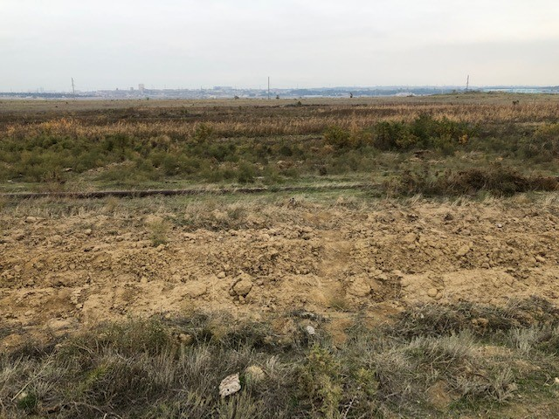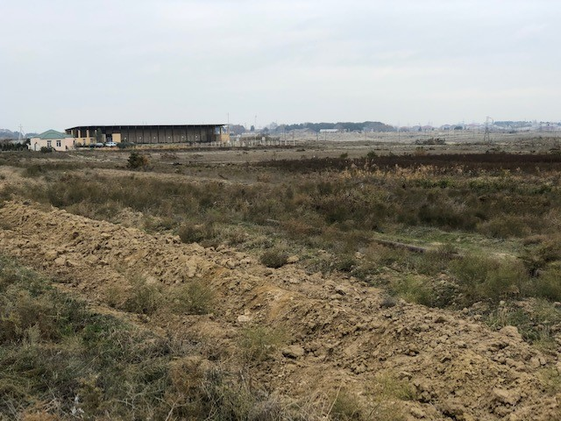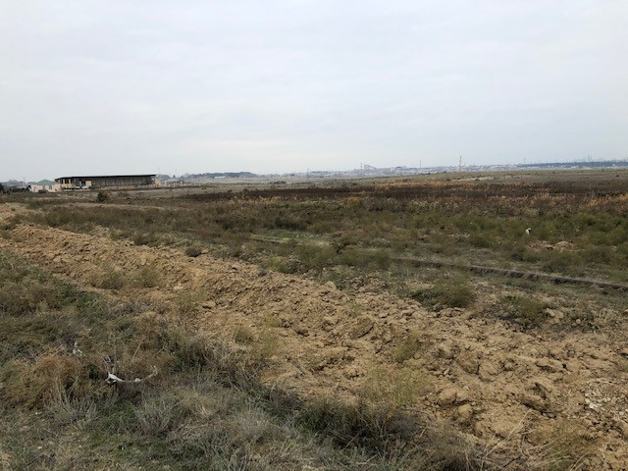
Figure 3. Current state of Absheron Nursery (Photo by Dr. Çağlar Başsüllü)

Forest Resources Assessment and Monitoring to Strengthen Forest Knowledge Framework in Azerbaijan (GCP/AZE/007/GFF) project will support the modernization of Absheron Nursery in 7 ha. The future support will include providing greenhouse, irrigation and drainage systems, establishment of seedling production parcels, procurement some of the modern machinery, tools, equipment, and capacity building activities (trainings) on production of high-quality planting materials by experienced and trained staff for production of high-quality planting seedlings with modern nursery technologies and techniques. Detailed activities for the modernatization is given in Section 3.

Nursery Modernization Plan

Mr. Ahmet Yalvaç and Dr. Çağlar Başsüllü conducted a mission to Baku/Azerbaijan between 01 and 09 December 2019 to address the technical planning considerations and estimate possible investment costs for modernization of Absheron Nursery. They also defined the necessary tools, equipment, and machinery to improve the conditions of the nursery. The following sections provide information on all technical planning considerations and investment plans.

Technical Planning Considerations (Design and Layout)

Absheron Nursery is mostly suitable for nursery operations in terms of nursery techniques and technical planning considerations. The total area of the nursery is 72 ha. However, modernization will take place in 7 ha. Ownership of the land belongs to Absheron Nursery Unit. Additional area is available if any increase in production capacity is planned in the future. Central coordinates of the permanent nursery are 40°11'58.46"N 49°38'09.02"E. The selected site is flat with slight slope however, 650 m drainage channels are needed due to heavy soil composition. Ground leveling is needed in some parts of the nursery; however, the cost of the ground leveling could be done by MENR as co-finance contribution.

The proposed nursery site is close to the lake. Water for irrigation purposes and for the use during the seedling production process will be provided from the lake with the support of water pumps and closed irrigation systems. Irrigation pool will be modernized to store the water.

Irrigation in replacement area will be done through drip irrigation systems; in bare-rooted and container seedling productions areas through sprinkling systems; and in the greenhouse and in sheltered area through foggy systems. Irrigation water will be directly provided from the lake or from the pool to the seedlings.

Nursery site has access roads for transportation of planting materials and customers. Available labor accommodates in close villages, to the proposed nursery site with easy access roads.

No flood risk is available. However, wind could be a problem during relevant seasons. Windbreaks must be established to avoid wind damage on seedlings.

Soil depth is good, but soil and water analyses will be conducted once the Nursery Modernization Plan and budget availability are cleared before the physical modernization of the nursery.

Electricity is available in the nursery. Telecommunication is available. Nursery site should be protected against wind and livestock with natural vegetation and/or manufactured structures. Fences will protect the nursery site.

The main roads in the nursery will be planned as 5 m and side roads will be planned as 3 m.

Flat areas will be used for the production of bare-rooted planting materials and container planting materials. Rough areas and partly flat areas will be used for the production of replaced seedlings.

The seedling production area will be 4 ha; roads and canals will be 1.5 ha, and other areas (facilities) will be 1.5 ha.

Design and layout of a nursery would increase the efficiency of seedlings production and minimize the lost time for nursery staff and workers. Production types (bare-root or container seedlings), nursery techniques (mechanization), production capacity, number of species types, use of a greenhouse, etc. defines the actual design and layout of a nursery (Liegel and Venator, 1987).

Absheron Nursery is operational; however, several issues need to be addressed. These issues are:

- Irrigation is done by using the traditional flood irrigation method,
- Lack of planned rotational seedling production system,
- Lack of parcels,
- Species are separated and produced in several locations,
- Nursery operations are irregular,
- Limited machinery, tools, and equipment,
- Lack of working and resting areas for staff and nursery workers,
- Lack of other facilities,
- Lack of adequate infrastructure
- Lack of modern irrigation systems,
- Limited knowledge on modern seedling production techniques,
- Use of non-standard seedling beds,
- Low production number of qualified seedlings,
- Lack of site protection,
- Limited container seedling production.

Hence, a decision was made to modernize Absheron Nursery to improve the conditions.

By considering these matters, Absheron Nursery will be modernized in 7 ha to have modern irrigation pool, conifer replanting/transplantation area, bare-rooted seedling production area, container seedling production area, seed extraction area, seedling material area, deciduous replanting/transplantation, greenhouse, manure area, machinery and equipment parking lot, seed storage room, administration facilities, sheltered working area, roads and parking area (Figure 4).

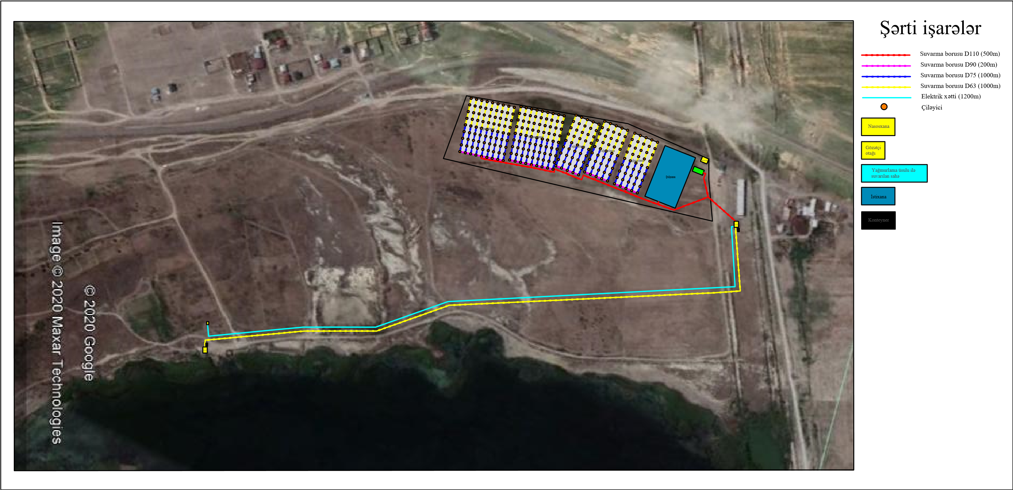

Figure 4. Design and Layout of Absheron Nursery

    - Bare-rooted Conifer and Broadleaved Seedling Production Area

The permanent nursery will be modernized to produce high-quality planting materials as follows:

Seedlings will be produced on beds. Soil preparation is followed by soil tear up by disk harrow or rotavator to establish seedling production beds (Figure. 5).

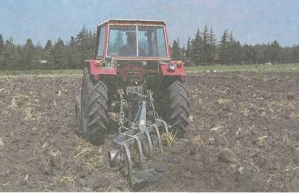
Figure 5. Soil preparation (Photo by GDF)

The surface of the seedling production beds should be smooth as much as possible, and the direction of the beds should be straight. This will enable the machinery working with a tractor, etc. generally, the width of the beds is 120 cm and the distance between the beds is 40 cm. Beds should be established 10 cm higher than the ground level to allow drainage (Figure 6). Beds should be established in the fall season, if possible. Fall and winter rain will lower the pH and lime levels. This is good for the production of high-quality planting materials.

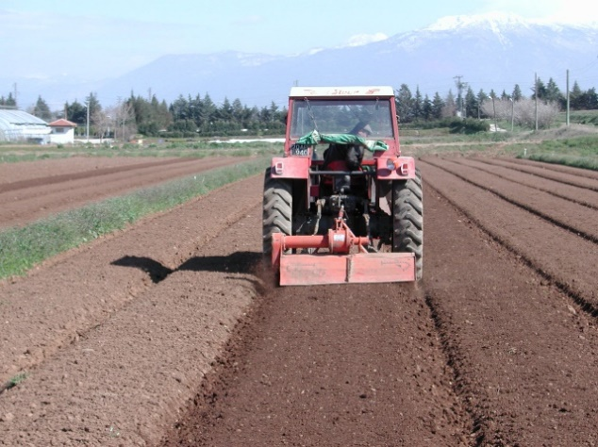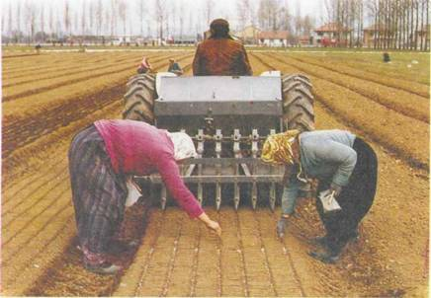
Figure 6. Establishment of seedling production beds and seed sowing (Photo by GDF)

As mentioned above, width of the beds is 120 cm. to sow seed on the beds, 7 lines should be established for conifers or 5 lines should be established for deciduous (broadleaved) species. In this case, the distance between the lines is 15-17 cm for conifers, 20-24 cm for deciduous species. Lines can be established with sowing machine (drill) or roller. The depth and the direction of the lines should be the same. Seeds can be sowed by hands or sowing machine (Figure 6).

Bare-rooted seedling production parcels will be established in two ha to produce conifer and deciduous species. In total, 350,000 conifer seedlings and 300,000 deciduous seedlings in Absheron Nursery (Figure 7). Sprinkler irrigation system will be used for watering purposes (Figure 8).

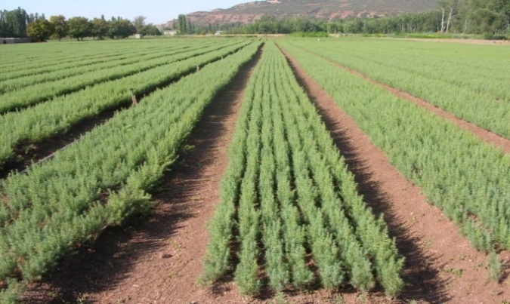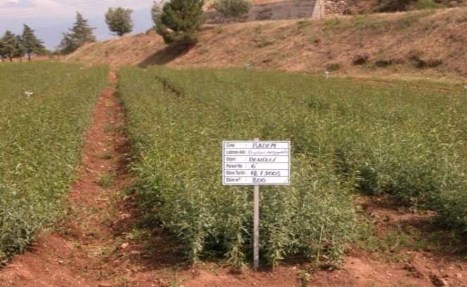
Figure 7. Bare-rooted seedling production in (Photo by GDF)

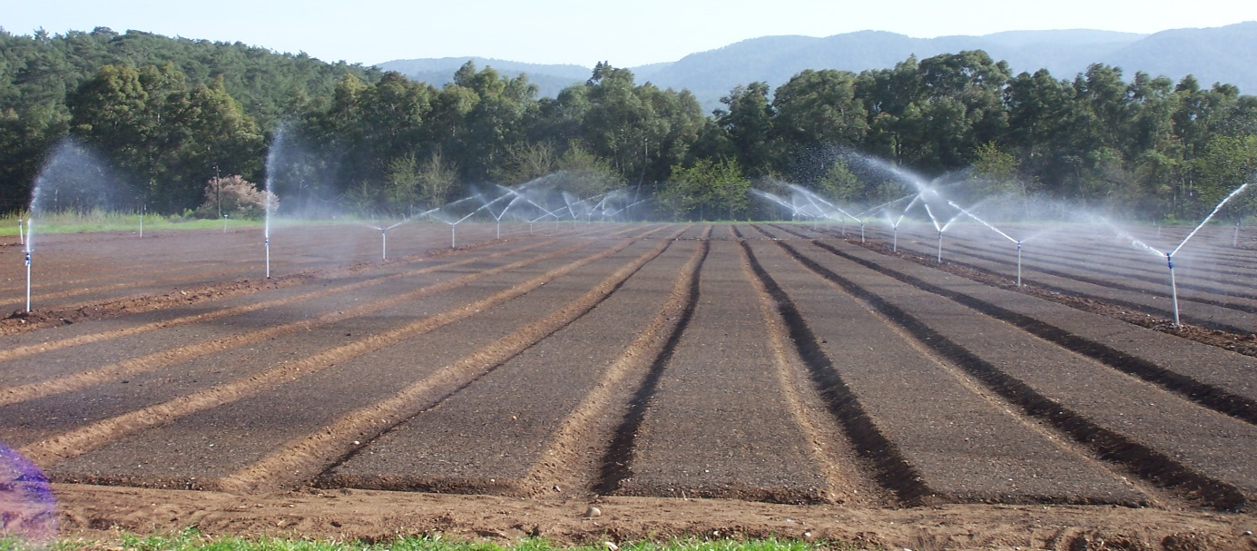
Figure 8. Plant watering with sprinkler system in bare-rooted seedling production beds (Photo by GDF)

Please see section 3.2.1 for required budget, items and technical specifications.

    - Container Seedling Production Area

Container seedling production can be done in two ways. First, one is to sow seeds directly to the containers. The second one is to produce seedlings is viols in greenhouse and replace the seedlings to containers or seedling production beds. Two or three seeds should be sowed to container maximum.

Polyethylene bags will be used as containers. The maximum size of these bags is 14-15*23cm. Three container seedling production parcels will be established in Absheron Nursery to produce around 500,000 container seedlings (Figure 9). Sprinkler irrigation will be used for watering purposes.

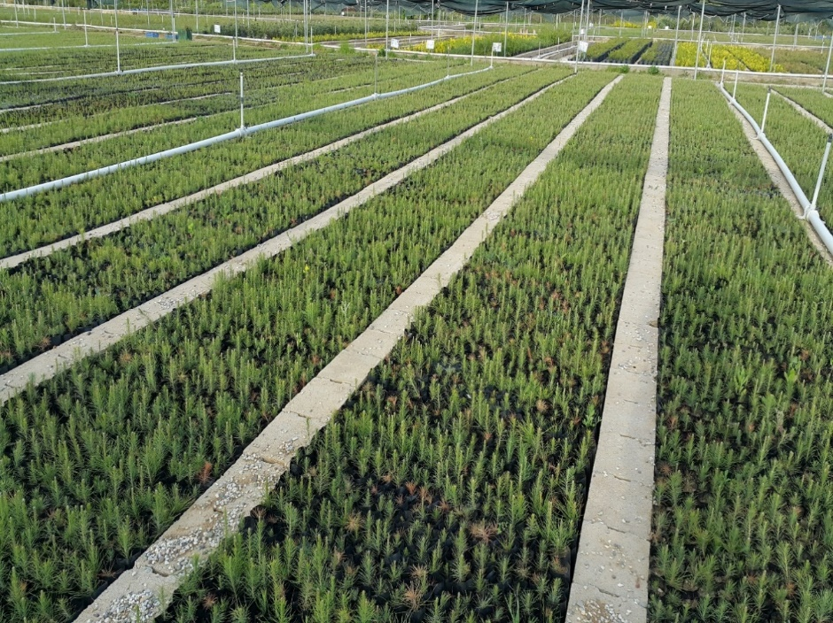
Figure 9. Container seedling production beds (Photo by Mr. Ahmet Yalvaç)

Seedling production beds will be established based on below techniques and Figures Figures 10, 11, 12, 13.

- The base of the container seedling production beds must have 1-2% slope,
- 20 cm depth drainage canals must be built in the middle of each bed. Drainage canals will be filled with cobble.
- Two-layered (two-fold) polyethylene cover must be spread on the ground to cover the drainage canals and container seedling production beds.
- Width of the container seedling production beds will be 120 cm; the distance between the beds that are called bed roads will be 20 cm.
- Bed roads will be paved with briquettes.
- Asphalt stone chips (No.4) will be spread on the polyethylene cover. Thickness of the stone chips will be 6-8 cm.
- Polyethylene bags or container cases (Type: Spencer) will be placed on the stone chips.

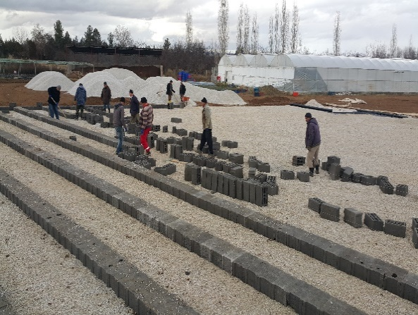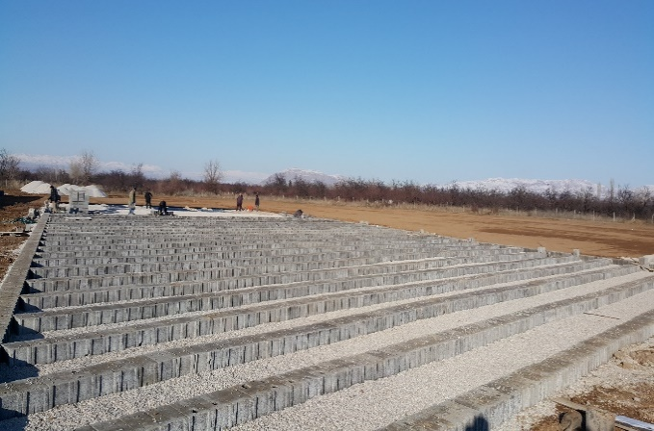
Figure 13. Establishment of container seedling beds (Photo by GDF)

Please see section 3.2.1 for the required budget, items, and technical specifications.

    - Seedling Production in Greenhouse

Absheron Nursery will have one greenhouse (Figure 14) to extend the season, produce high-quality planting materials, have a higher yield and save money. The greenhouse will be supported by a sheltered area to ensure seedlings adapt the outside conditions once they are removed from the greenhouse. Please see section 3.2.2 for required budget and Annex for technical specifications.

200m² (9,6m*20m) greenhouse will be built with climate, air conditioning, and irrigation system. Net area for seedling production will be 185m². The greenhouse is covered with a double light-stabilized plastic film with a protection against destruction of UF radiation with anti-condensation coating, the warranty period is 60 months.

270 seedlings will be produced in 1m² by using viols, which carry 45 seedlings in each (Figure 15). The total number of seedlings will be around 50,000 (185x270=49,950). The basic technical features of the greenhouse are given below.

- Steel construction and body - area 192 m2, length - 20.0 m, distance between arches: 2.00 m
- Sidewalls are covered with transparent polycarbon,
- Ceiling is covered with transparent UV-IREVA-added greenhouse nylon/plastic,
- Climate mechanism (Double circulation electric heating and cooling with fan)
- Watering (Rail top foggy irrigation system)
- Lighting.
- Arch made of galvanized pipe Ø 60 mm x 2 mm
- Ends Polycarbonate 8 mm
- Sliding gates on each side of the greenhouse 3.2 mx 2.2 m
- A double layer of a film of 180 microns. anti-drip
- The system of pressurization of air in the inter-film space

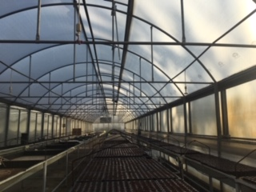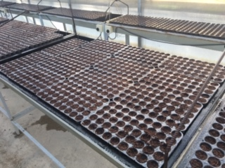
Figure 14. Seedling production in a greenhouse (Photo by Mr. Ahmet Yalvaç)

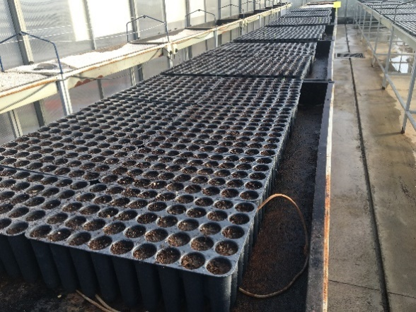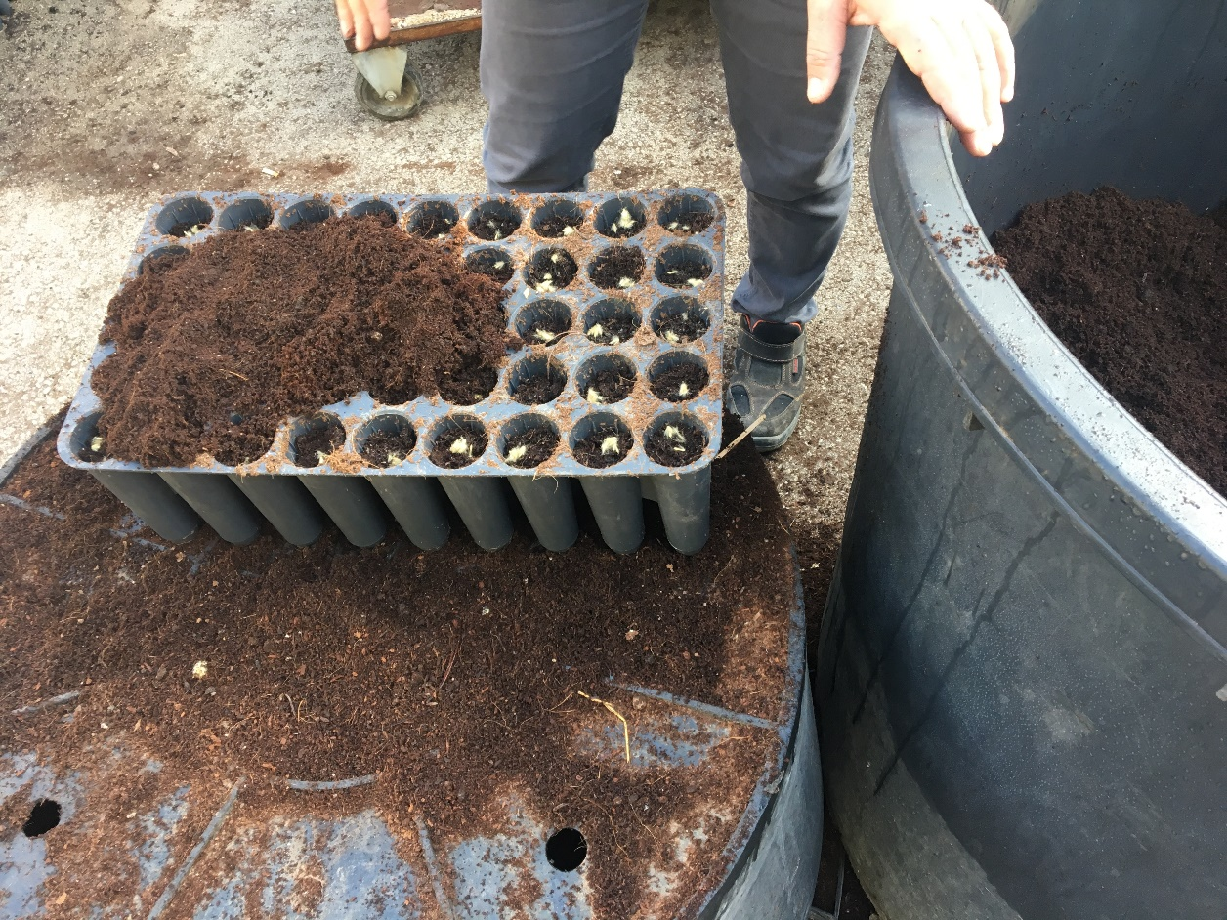
Figure 15. Viols (Photo by Mr. Ahmet Yalvaç)

    - Sheltered Area

Seedlings in the viols, which will be produced in the greenhouse, will be taken to poly bags with various diameters to produce container seedlings.

A sheltered container seedling production area (total 5,400 m²) with an irrigation system will be established to ensure that seedlings are easily adapted to outside conditions once they are taken from the greenhouse (Figure 16). Polybags will be placed in this sheltered area for 1 to 3 years. Preferably, 0.2*0.3m sized poly bags will be used to produce 36 seedlings in 1m². In total, 144,000 seedlings will be produced in 5400m² of the sheltered area. 200 m² of the sheltered area will be used for other purposes. The foggy systems will be used in a sheltered area for watering purposes. Manure will be provided to seedlings.

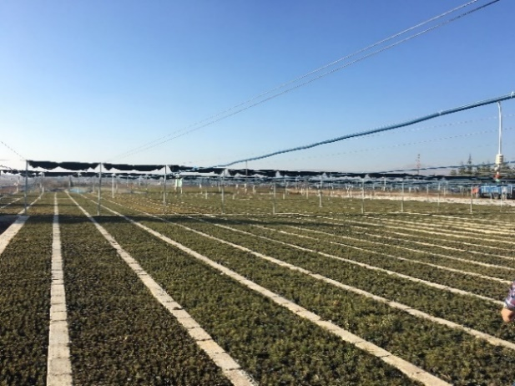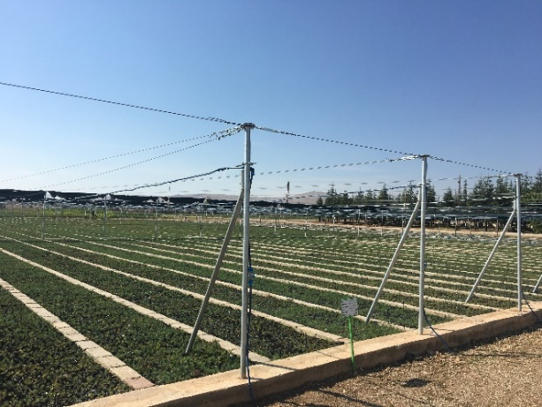
Figure 16. Sheltered area (Photo by Mr. Ahmet Yalvaç)

    - Seedling Production Capacity

The total annual seedling production capacity will be around 1,200,000 seedlings. Breakdown of this capacity is given below. Moreover, a material garden will be established with 400 mother plants to produce plant production material.

Bare-rooted broadleaved and conifer: 300,000; 350,000
Containered: 504,000 and greenhouse: 50,000

    - Modernization of Working Areas and Facilities

Working areas and facilities should be modernized for nursery staff and workers to enable them to work efficiently. Therefore, laptop computers and printer (scanner and photocopier included) should be procured, and manure facility, closed working area/soil storage/sieve area (shelter) and irrigation pool should be established or modernized.

The administrative office for the nursery staff will be restored. Existing penthouse will be restored to store machinery, equipment, tools, and other stuff. Penthouse will include rolling doors. Three sections of the penthouse will have shelves (Figure 17).

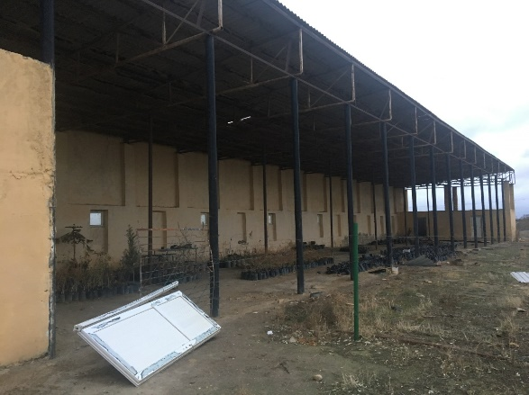
Figure 17. Existing shelter for renovation (Photo by Mr. Ahmet Yalvaç)

Concrete rooms next to the penthouse will be restored to store tools and equipment such as manure, fertilizers, seedling bags, pots, etc.) (Figure 18).

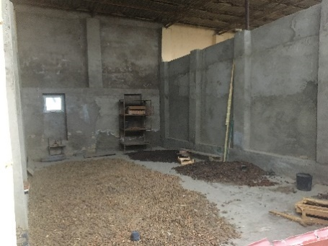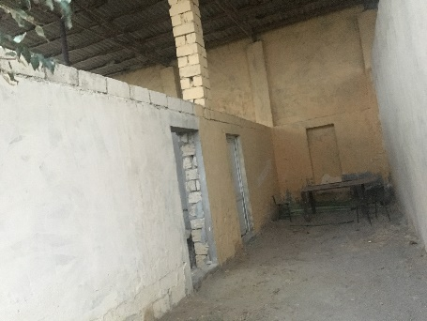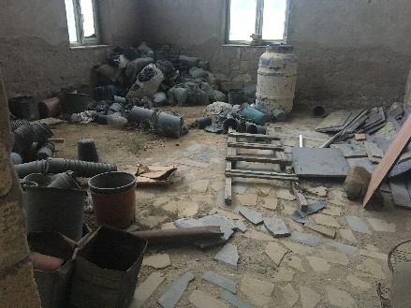
Figure 18. Existing stores for renovation (Photo by Mr. Ahmet Yalvaç)

A two-compartment manure storage area will be constructed by MENR in an open area to store animal manure (Figure 19). The size of the manure storage area will be 3m*6m*3m (height*most*length).

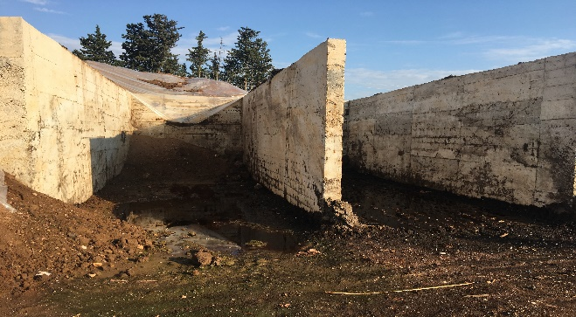
Figure 19. Manure store area (Photo by Mr. Ahmet Yalvaç)

Please see section 3.2.3 for the required budget and technical specifications.

    - Fencing

Absheron Nursery should be protected against wind and livestock with natural vegetation and/or manufactured structures. As of now, no natural vegetation or manufactured structures exist in the nursery site. Therefore, Absheron Nursery needs metal fences (650 m) and establishment of windbreaks (to be done by MENR). Please see section 3.2.4 for required equipment and budget.

    - Modern Machinery and Equipment

Absheron Nursery should be equipped with modern machinery and equipment to improve the seedling production capacity and produce high-quality seedlings. Proposed machinery and equipment are tractor with bucket, tractor with bucket, tipper trailer, plow, rotavator, cultivator, bucket with loader, root cutting knife, drill (sowing machine), hoeing machine, pad machine, seed roller, clamping roller, motorized sieve, strimmer (weedeater), knapsack sprayer, GPS and tape measure. Please see section 3.2.5 for the required budget and technical specifications.

    - Irrigation and Drainage Systems

Modern irrigation systems will be established in Absheron Nursery. This will save water and money and will enable efficient grow of high-quality planting materials. Please see section 3.2.6 for the required budget and items and Annex for technical specifications.

    - Consumables

Nursery operations require various consumable materials during seedling production period. Some of the consumables are manure, viols, torf, plastic containers, wastebins, shovel, harrow, etc. Please see section 3.2.7 for required budget, items, and technical specifications.

List of Items (Goods, works and other services) under Project Budget

    - Establishment of Seedling Production Parcels

Item | Tecnical Specifications | Unit of Measurement | Unit Price (USD) | Total Price (USD)
Container Seedling Production Parcel | Please see Annex | 3 parcels | 12,000 | 36,000
Bare-rooted Seedling Production Area | Please see annex | 2 parcels | 6,000 | 12,000
Drainage Canal | Please see Annex | 2,600m³ | - | 2,000
Total |  |  |  | 50,000
    - Greenhouse and Sheltered Area

Item | Tecnical Specifications | Unit of Measurement | Unit Price (USD) | Total Price (USD)
Greenhouse | Please see Annex | 1 greenhouse | 60,000 | 60,000
Sheltered Area | Please see Annex | 1 sheltered area | 15,000 | 15,000
Total |  |  |  | 75,000

    - Modernization of Working Areas and Facilities

Item | Tecnical Specifications | Unit of Measurement | Unit Price (USD) | Total Price (USD)
Laptop Computer | Please see Annex | 1 laptops | 1,000 | 1,000
Printer (Scanner and Photocopier included) | Please see Annex | 1 printer | 500 | 500
Renovation of sheltered area | Please see Annex | Lump sum |  | 10,000
Renovation of Irrigation Pool | Capacity: 100m³  Please see Annex | 1 pool | 2,000 | 2,000
Generator | Please see Annex | 1 generator | 500 | 500
Total |  |  |  | 14,000

    - Fencing

Item | Tecnical Specifications | Unit of Measurement | Unit Price m2 (USD) | Total Price (USD)
Panel fence (transportation and assembling included) | Minimum Reguirements:  Wire fences at 2.5 meters of width and 2.5 meters of height. High galvanized wire  Please see Annex | 0,6 km, 2.500 m2 | 10 | 15,000
Total |  |  |  | 15,000

    - Modern Machinery and Equipment

Item | Technical Specifications | Unit of Measurement | Unit Price (USD) | Total Price (USD)
Tractor with bucket | Minimum Reguirements:  Please see Annex | 1 tractor with bucket | 30,000 | 30,000
Tipper trailer | Minimum Reguirements:  Please see Annex | 1 tipper trailer | 1,600 | 1,600
Plow | Minimum Reguirements:  Please see Annex | 1 plow | 600 | 600
Rotovator | Minimum Reguirements:  Please see Annex | 1 rotavator | 1,500 | 1,500
Cultivator | Minimum Reguirements:  Please see Annex | 1 cultivator | 1,000 | 1,000
Bucket with loader | Minimum Reguirements:  Please see Annex | 1 bucket with loader | 2,000 | 2,000
Root cutting knife | Minimum Reguirements:  Please see Annex | 1 root cutting knife | 700 | 700
Drill (Sowing machine) | Minimum Reguirements:  Please see Annex | 1 drill | 3,000 | 3,000
Hoeing machine | Minimum Reguirements:  Please see Annex | 1 hoeing machine | 4,000 | 4,000
Bed machine | Minimum Reguirements:  Please see Annex | 1 bed machine | 500 | 500
Seed Roller | Minimum Reguirements:  Please see Annex | 1 seed roller | 1,500 | 1,500
Clamping roller | Minimum Reguirements:  Please see Annex | 1 clamping roller | 1,500 | 1,500
Motorized sieve | Minimum Reguirements:  Please see Annex | 1 moterized sieve | 2,000 | 2,000
Strimmer (weedeater) | Minimum Reguirements:  Please see Annex | 2 strimmers | 200 | 400
Knapsack sprayer | Minimum Reguirements:  Please see Annex | 2 knapsack sprayers | 200 | 400
Measuring tape (5 m) | Minimum Reguirements:  Please see Annex | 8 measuring tapes | 5 | 40
Total |  |  |  | 50,740

    - Irrigation and Drainage Systems

Irrigation system will be established for a whole Nursery system, including greenhouse and seedling production at open areas. Please see Annex for technical specifications. The estimated budget is USD 70,000.

3.2.7. Consumables

Item | Tecnical Specifications | Unit | Unit Price (USD) | Total Price (USD)
Staking cord | Minimum Reguirements:  Please see Annex | 10 Bobbin | 20 | 200
Manure (NPK Complex 15-15-15) | Minimum Reguirements:  - Please see Annex | 5 tons | 500 | 2,500
Viols for 45 seedlings | Minimum Reguirements:  Please see Annex | 2,500 viols | 1 | 2,500
Growing medium/Potting soil | Minimum Reguirements:  Please see Annex | 200 m³ | 30 | 6,000
Liquid Fungicide | Minimum Reguirements:  Please see Annex | 100 Liters | 20 | 2,000
Granulated sulphur | Minimum Reguirements:  Please see Annex | 0.5 tons | 5,000 | 2,500
Nylon package | Minimum Reguirements:  Please see Annex | 1,000 kg | 1 | 1,000
Plactic wastebin for Office | Minimum Reguirements:  Please see Annex | 20 watebins | 5 | 100
Hoe (anchor) | Minimum Reguirements:  Please see Annex | 50 hoes | 10 | 500
Spade | Minimum Reguirements:  Please see Annex | 10 spades | 10 | 100
Shovel | Minimum Reguirements:  Please see Annex | 10 spades | 10 | 100
Spade and Shovel Handle | Minimum Reguirements:  Please see Annex | 20 handles | 10 | 200
Pickax | Minimum Reguirements:  Please see Annex | 10 pickaxes | 10 | 100
Harrow | Minimum Reguirements:  Please see Annex | 10 harrows | 10 | 100
Total |  |  |  | 17,900

Detailed List of Items (Goods, works and other services) under Municipataly and MENR Budget

The road from Ceyranbatan to Absheron needs to be stabilized or even asphalt road would be needed. This work should be done by the municipataly.

Item | Tecnical Specifications | Unit | Unit Price (USD) | Total Price (USD)
Stabilized road | Minimum Reguirements:  Asphalt depth: 10 cm  Asphalt wide: 6 m | 3km | 10,000 |  | 30,000
Total |  |  |  |  | 30,000

Office building, open shelter area, guard office are old and damaged, and working conditions are not sufficient for effective working. The working area of the staff needs to be improved immediately with a new office building, new closed shelter area including office equipment such are tables, chairs, computers, heating systems, a gas pipeline for greenhouses, electricity lines, etc. Moreover, the nursery should be protected with fences.

Restoration/renovation of the office building, shelter area and guard building including procurement of necessary furniture, establishment of workers facility, a gas pipeline for greenhouse, electricity lines and vehicles could be partly covered by MENR as a co-finance activity. Necessary permissions related to gas pipeline for greenhouses and electricity lines (i.e. transformer) possible associated costs should be arranged and covered by MENR.

Item | Technical Specifications | Unit | Unit Price (USD) | Total Price (USD)
Office building renovation | Please see Annex | Lumpsum | 30,000 | 30,000
Guard office renovation | Please see Annex | Lumpsum | 3,000 | 3,000
Office furniture | Please see Annex | Lumpsum | 5,000 | 5,000
Other renovation | Please see Annex | Lumpsum | 2,000 | 2,000
Ground leveling | Please see Annex | Lumpsum | 10,000 | 10,000
Total |  |  |  | 50,000

Investment Plan under Project Budget

The estimated budget for modernization of Absheron Nursery is USD 307,272.00. The detailed investment plan is given in Table 2.

Table 2. Investment Plan
No | Activity | Price (USD)
1 | Establishment of Seedling Production Parcels | 50,000
2 | Greenhouse and Sheltered Area | 75,000
3 | Water reservoir and shelter renovation | 14,000
4 | Fencing | 15,000
5 | Modern Machinery and Equipment | 50,740
6 | Irrigation and Drainage Systems | 70,000
7 | Consumables | 17,900
Total Cost |  | 292,640.00
5% Unexpected Cost |  | 14,632.00
Grand Total |  | 307,272.00

Investment Plan under Municipataly Budget

The estimated budget for modernization of the road is USD 33,000. The detailed investment plan is given in Table 3.

Table 3. Investment Plan

No | Activity | Price (USD)
1 | Stabilized road | 30,000
Total Cost |  | 30,000.00
5% Unexpected Cost |  | 1,500.00
Grand Total |  | 31,500.00

Investment Plan under MENR Budget

The estimated budget for modernization of buildings and procurement of furnitures and a dumper truck is USD 74,800. The detailed investment plan is given in Table 4.
Table 4. Investment Plan

No | Activity | Price (USD)
1 | Office building renovation | 30,000
2 | Guard office renovation | 3,000
3 | Office furniture | 5,000
4 | Other renovation | 2,000
5 | Ground leveling | 10,000
Total Cost |  | 50,000.00
5% Unexpected Cost |  | 2,500.00
Grand Total |  | 52,500.00
Total investment is estimated at USD 391,272.

Recommendations for Trainings

Below training needs were defined during the consultation meetings with MENR and Absheron Nursery staff. Detailed training programmes will be developed in the beginning of 2020. All trainings will be organized by FAO and the cost of the trainings will be coverd by FAO.

- Training on introduction of new/modern seedling production techniques including new species varieties,
- Trainings on seedling production,
- Awareness-raising trainings on plant watering techniques and technologies for farmers
- Capacity building trainings on seed collection, seed storage, seed preparation, ground preparation, seed sowing, container seedling production, germination, watering techniques, maintenance, use of machinery and equipment, pest and disease control, nursery infrastructure, and cuttings in seed and transplanting beds,
- Trainings on principles of creating permanent forest seed stands, seed gardens, and seed orchards.

Workplan

Activity | 2020
Activity | Q1 | Q2 | Q3 | Q4
Preparation of Nursery Modernization Plan (Jan-Feb 2020)
The tender process for goods, works and other services (March-April2020)
Evaluation of bids and providing clearances (April-May2020)
Delivery of procured items (May-June 2020)
Modernization of Absheron Nursery (May-Sep 2020)
Development of training programmes (Feb 2020)
Trainings (Throughout the year when planned)

Proposal for Upscaling at the National Level

Azerbaijan has committed to forest and landscape restoration/rehabilitation, decreasing forest and land degradation, enhancement of forest stocks, combating with desertification and climate change through ambitious pledges in numbers of hectares to be restored/rehabilitated, reforested and sustainably managed.

These commitments were submitted globally under the UNFCCC (GoA, 2015a; GoA, 2018); under Paris Agreement and its INDCs for establishment of new forest areas, windbreaks for water and land protection and urban and roadside greenery (GoA, 2015b); under the United Nations Convention on Biological Diversity (UNCBD) for conservation, restoration and sustainable management and use of biodiversity, ecosystems and ecosystem services (GoU, 2014); and under FAO strategic objectives to increase and improve provision of goods and services from agriculture, forestry and fisheries in a sustainable manner; under FAO regional priority 3 for natural resource management, including climate change mitigation and adaptation; and under FAO CPF to strengthen national capacity for sustainable, equitable and efficient forestry, land and water resources management between 2016 and 2020 (CPF, 2016).

As the implementation of these commitments happens, different actors from national to local scales must develop and negotiate the "what, where, when and how" of specific forest and other land restoration/rehabilitation plans and SFM/Sustainable Land Management (SLM) strategies.

Implementation and upscaling of national activities to support the global efforts on forest and other lands restoration, decreasing forest and land degradation, enhancement of forest stocks, combating with desertification and climate change require an ‘order-of-magnitude’ increase in the provision of high-quality planting material through modern nursery network in Azerbaijan.

Nursery Modernization Plan will support the GCP/AZE/007/GFF project to deliver global environmental benefits related to climate change mitigation, the reversal of land degradation processes and SFM.

The current capacity of Absheron Nursery is insufficient to meet the local scale future demand, and it is essential that the necessary increase in nursery production does not trade quantity for quality of plant material.

Nursery Modernization Plan is providing clear guidelines, necessary information on technical planning considerations and investment costs for the modernization of Absheron Nursery. Based on this example, it will be possible to upscale and develop nurseries network at the national level.

Different stakeholders and decision-makers at national, regional and local scales shall be interviewed to receive their feedback regarding the barriers and strategies for upscaling the development of modern nurseries in Azerbaijan. Therefore, Nursery Modernization Plan provides a road map on technical planning considerations and investment plans establishing/modernizing the nursery network in the country and in other countries where similar conditions exist.

Nursery Modernization Plan suggests modern nurseries with high technology facilities, machinery, equipment, tools, best seed, and seedling production practices. Therefore, successful, standard, planned, sufficient and sustainable high-quality seed and seedling production will be ensured throughout the year in Absheron Nursery by leaving outdated conditions and practices, which will result in a high survival rate of seedlings and success in SFM practices, reforestation and restoration/rehabilitation areas at the national level. New technologies and techniques will support the upscaling of high-quality seed and seedling production and development of the nursery sector across the country. If possible, regional demand on seeds and seedlings would also be guaranteed from Absheron Nursery and future modern nurseries.

Nursery Modernization Plan suggests producing high-quality planting materials to improve the livelihoods of local farmers. This will be ensured by the production of income-generating species including fruit and nut trees and medicinal, aromatic, and ornamental species. Absheron Nursery will support the local farmers by providing seedlings to establish gardens of fruit and nut trees including medicinal and aromatic plants and ornamental plants.

Production of various types of seeds and seedlings in modern nurseries will support biodiversity conservation and expand habitats for biodiversity in the forests of Azerbaijan.
Absheron Nursery will produce seeds and seedlings to establish shelterbelts around the agricultural areas to reduce the adverse effects of erosion, support crop production in terms of food safety, and stabilize the soil loss through river and channel sides.

Absheron Nursery will create enabling environment for employment of local people, especially women to empower women participation in nursery activities and this will lead the improvement of livelihood and creation of new jobs and increased opportunities for income generation.

Absheron Nursery will create enabling environment for the development of new green ideas from local level to the global level through playing a role in urban and rural development including supporting the sustainable use of all land-use types.

Absheron Nursery will support the demand of future local, national and regional sustainable resource management projects.

Absheron Nursery will also serve as a training centre, knowledge and information-sharing platform and demonstration site at the local, national and regional level by including neighboring countries, seedling producers and farmers.

Absheron Nursery will improve communication on objectives and environmental, social and economic benefits of nurseries; support Azerbaijan participation in global initiatives and platforms and improve rural extension support (Bull et al., 2018; Strassburg et al., 2018; Stanturf et al., 2019).

Absheron Nursery requires experienced and trained staff with updated organizational capacity. Therefore, the modernization of Absheron Nursery may lead to improve governance arrangements and political environment through participatory planning approach (Bull et al., 2018; Strassburg et al., 2018; Stanturf et al., 2019).

Absheron Nursery with high-quality planting materials may lead the establishment of a certification system for the production of certified seeds and seedlings.

Investment costs for modernization of Absheron Nursery will provide a perspective to find adequate funding sources involving international, national and private stakeholders and institutions to overcome the financial barriers (Bull et al., 2018; Strassburg et al., 2018; Stanturf et al., 2019).

Mainstreaming and upscaling the use of the Nursery Modernization Plan will be ensured by capacity building events such as trainings to improve the capacities of all stakeholders. Moreover, trainings on new technologies and new techniques on seedling production will also enhance the knowledge of producing high-quality seedlings for various forestry activities.

Model nursery practices and various forestry activities in the field will raise awareness amongst policy and decision-makers and local stakeholders for enhancing the critical role of forest ecosystems and forestry sector in Azerbaijan for the nature conservation.

Monitoring and evaluation activities will assist nursery managers to focus on the gaps and find options/solutions to improve the conditions in Absheron Nursery to upscale the best practices in Azerbaijan.

Moreover, robust monitoring and evaluation system for the quality of seeds and seedlings and their success in forestry activities and management interventions will provide a basis to improve the quality of production process, remove barriers, and cost efficiency estimations (Stanturf et al., 2019) for the use of new technologies and techniques could reduce the total expenditures and future planning considerations.

Lastly, Nursery Modernization Plan will be a supporting tool for modernization of Absheron Nursery, which targets the production of plant materials for rehabilitation/restoration, SFM, and horticulture (i.e. fruit and nut trees, medicinal, aromatic and ornamental plants).

References

Bull, G., Boedhihartono, A., Bueno, G., Cashore, B., Elliott, C., Langston, J., Riggs, R., Sayer, J., 2018. Global forest discourses must connect with local forest realities; International Forestry Review, Vol. 20; DO - 10.1505/146554818823767573.
CPF, 2016. FAO Country Programming Framework for Azerbaijan, http://www.fao.org/3/a-bp566e.pdf.
GoA, 2014. The Fifth National Report of the Republic of Azerbaijan on the Conservation of Biological Diversity. 64p, Baku.
GoA, 2015a. Information to the United Nations Framework Convention on Climate Change (UNFCCC) on the Intended Nationally Determined Contribution (INDC) of the Republic of Azerbaijan. 3p, Baku.
GoA, 2015b. Third National Communication of the Republic of Azerbaijan under the UNFCCC. 89p, Baku.
GoA, 2018. Second Biennial Update Report of the Republic of Azerbaijan to UN Framework Convention on Climate Change. 125p, Baku.
Haase, D.L., Davis, A.S., 2017. Developing and supporting quality nursery facilities and staff are necessary to meet global forest and landscape restoration needs. Reforesta 4:69-93. DOI: https://dx.doi.org/10.21750/REFOR.4.06.45.
Liegel, L.H., Venator, C.R., 1987. A Technical Guide for Forest Nursery Management in Caribbean and Latin America. United States Department of Agriculture, Forest Service, Southern Forest Experiment Station, General Technical Report SO-67, 156p, Louisiana.
Stanturf, J., Kleine, M., Mansourian, S., Parrotta, J., Madsen, P., Kant, P., Burns, J., Bolte, A., 2019. Implementing forest landscape restoration under the Bonn Challenge: a systematic approach; Annals of Forest Science; Vol. 76; DO - 10.1007/s13595-019-0833-z.
Strassburg, B., Beyer, H., Crouzeilles, R., Loyola, R., 2018. Strategic approaches to restoring ecosystems can triple conservation gains and halve costs; Nature Ecology & Evolution; Vol. 1; DO - 10.1038/s41559-018-0743-8.

Annex: Technical Specifications

Tech Specifications for Items to be provided by the Project

- Technical Specifications for Laptop Computer

Minimum Requirements:
- 7th Generation Intel® Core™ i5-7300HQ Quad Core (6MB Cache, up to 3.5 GHz)
- Windows 10 Home 64-bit English
- 8GB, 2400MHz, DDR4 up to 32GB
- 1TB 5400 rpm SATA Hard Drive
- NVIDIA® GeForce® GTX 1050 with 4GB GDDR5 graphics memory
- 15.6-inch FHD (1920 x 1080) Anti-Glare LED-Backlit Display, Non-touch)

- Technical Specifications for Printer

Minimum Requirements:
- Functions: Print, copy, scan and optional fax
- Resolution (black): Up to 1200 x 1200 dpi
- Resolution technology: 300 dpi, 600 dpi,
- Monthly duty cycle: Up to 150,000 pages
- Print Technology: Laser
- Display: 8.0 in (20.3 cm), touchscreen (1024x768), LCD (color graphics), smooth gesture, enabled touchscreen
- Paper trays: 2
- Connectivity: 1 Hi-Speed Device USB 2.0; 2 Hi-Speed USB 2.0 Host; 1 Gigabit Ethernet; 1 Hardware Integration Pocket
- Memory: 1.25 GB (printer); 512 MB (Scanner)
- Paper handling input: 100-sheet multipurpose Tray 1, 550-sheet input Tray 2, automatic duplex printing
- Paper handling output: 250-sheet output bin
- Duplex printing: Automatic
- Warranty: One-year
- Toner cartridge
- Power cord

- Technical Specifications for Greenhouse

Type, amount: 1 piece at 9.60x20.00 m size

Design principles:

- Semi-automized management system with Double Top Ventillation, Steel construction system, galvanized production system
- Greenhouse systems should be fully bolted and modular, corrosion and rustproof as well as durable in accordance with the standards, robust and durable, healthy and successful plant production will be required to provide the ideal climate and comfort conditions in a balanced way.
- All materials used in the Greenhouse Manufacturing shall be of the first quality and the standards that determine the required performance criteria according to CE and / or G and its properties.

TECHNICAL SPECIFICATIONS OF VERTICAL ROOF GREENHOUSE

Greenhouse type | Vertical roof greenhouse
Greenhouse tunnel opening | 8.00 m.
Column spacing | sides 2,5m
Brackets range | 2,5 m
Groove height | 3.5 m
Peak height | 5.25m
Number of tunnels | 1
Greenhouse width | 9.60
Greenhouse length | 20m
Greenhouse | 192 m²
Wind load | 80 km/h
Plant load | 25 kg/m²
Snow load | 25 kg/m²
Accessory load | 10 kg/m²
Type of ventilation | Double top ventillation

CARRIER COLUMNS
With these high strength and static structure properties, the supporting columns will provide higher installation of greenhouse and at the same time provide easier climate control in higher greenhouse and reach the required high ventilation rate.

Side columns | 80X80X2mm 3500 mm
Center columns | 80X80X2mm 3500 mm
Facade columns | 80X80X2mm 5250 mm
Anchors | 70X70X2mm 1000 mm
Front beam profile | 40X80X2mm 3500 mm

VERTICAL ROOF ELEMENTS
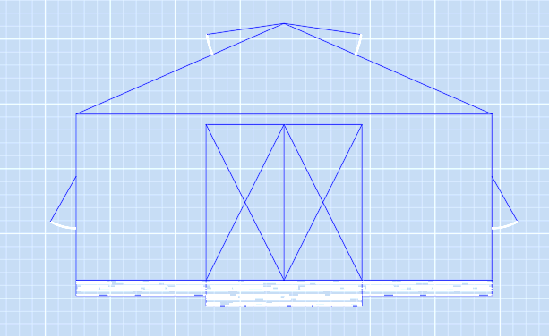
M1 Truss
Crossing truss profiles

For a balanced distribution of the static loads, the truss will be as the plant suspension axis is divided into 2 equal parts, all connections are knotted to the load equilibrium points, and the truss profiles shall be Ø60 - Q27 mm in diameter according to the load equilibrium calculations and shade rates.

Truss spring tube | Ø60X1,5mm galv. pipe
Tepe ridge | t:1mm gal. sac
For M2 shears
Truss spring pipe | Ø 60X1,5mm galv. pipe
Truss vertical support tensioner | Ø 27X1,5mm galv. pipe
Truss vertical support pipe | Ø 27X1,5mm galv. pipe
Truss cross tube | Ø 27X1,5mm galv. pipe
Truss beam pipe | Ø 42X1,5mm galv pipe

SIDE AND TOP CONNECTION PROFILES

Top profile of 32 size | 32X1,2mm galv. sac
Ventilation box profile | 32X1,2mm galv. sac
Side box profiles | 32X1,2mm galv. sac
Front box profiles | 32X1,2mm galv. sac
Double border front | 78X2.0mm galv. sac
Double face spring profile | 78X2mm galv. sac

Roof ventilation system

There will be a ventilation system that provides a high level of lift-up opening to one side at 3000 mm width and special manufacturing hinge system, bearing shaft bearings will minimize friction and power losses. Switched geared motors will be used for opening the windows. Shafts shall be galvanized in dimensions of 34x2 mm and buckling and load losses shall be minimum.

Reducer gearboxes | 50Hz 380V
Rack and pinion gear | 2,5mm galv. sac
Bearing shaft bearing | 1,5mm galv. sac
Ventilation shaft pipe | Ø 34X2.0mm galv. pipe
Ventilation profile | 30X50X1,5 mm

WIND TENSIONS

In the greenhouses, roof trusses shall be secured against the wind loads by roof tensioners, and the system shall be secured by side and inner column tensioners and roof wind tensioners against the different wind directions.

M1-M2 wind connection | Ø 27X1,5 mm galv. pipes
Forehead cross tensioner | Ø 42X1,5mm galv. pipes
Side column tensioners | Ø 27X1,5mm galv. pipes

CONNECTORS

All the bolts and nuts used in the greenhouse assembly are galvanized and the clamps that connect all the elements made of galvanized sheet will be molded in a special form and design and will be able to be welded and modular assembly.
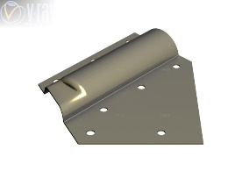 |  | 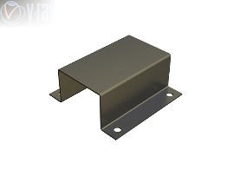 | 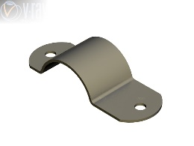 | 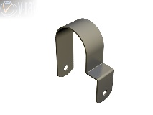
Y EK Right | Y EK Left | Y EK KEL. | Y KEL. Additional | Front KEL.

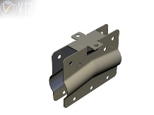 | 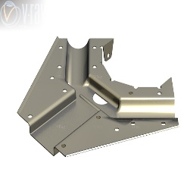 | 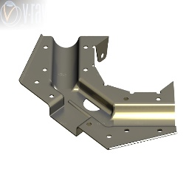 | 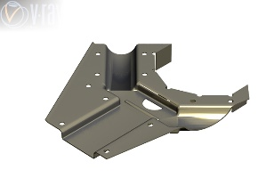 | 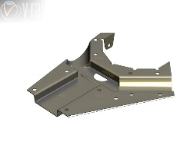
Top KEL. | Y KEL. Full | Y. KEL. Right | Y KEL. Left | Y KEL. Middle
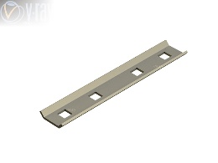 | 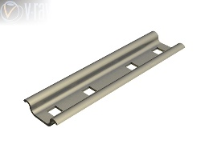 | 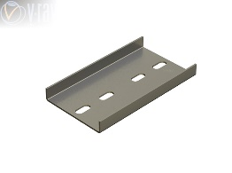 | 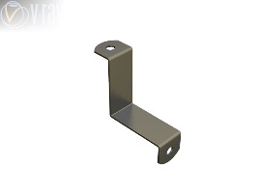 | 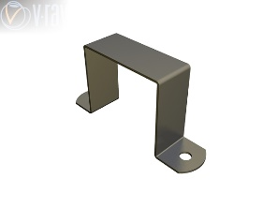
32 LİK EK K | 78 LİK Internal KEL. | 78 LİK U KEL. | Corner. K. | 32 LİK Side KEL.

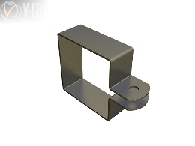 | 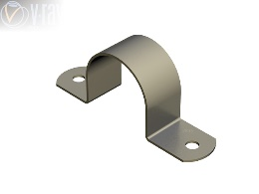 | 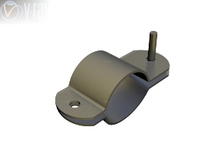 | 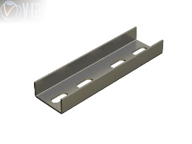 | 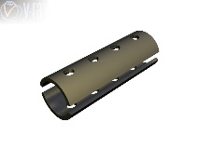
Side full. K | 60 LIK connector. K. | Front connector. | 32 LİK Connector K | Air pipe. K

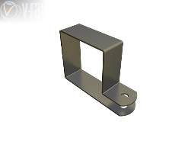 | 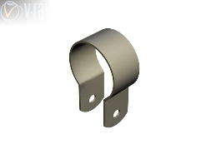 | 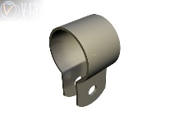 | 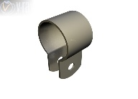 | 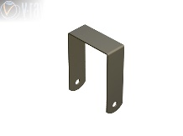
Cross K | 60 LIK KEL. | 42 LİK KEL. | 34 LÜK K. | Front Krish K

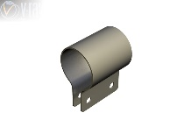 | 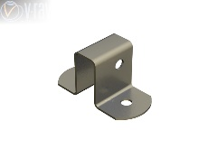 | 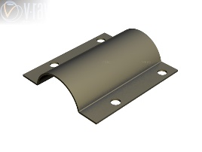 | 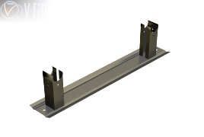 | 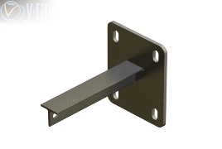
Hook connector. KEL. | HAV. PR. UÇ. KEL. | Y.KEL. YAY KAR. | Suport MON. TAK. | 51.LİK Supporter

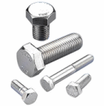
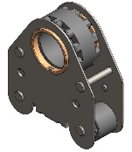

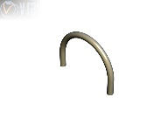 | 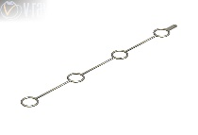 | 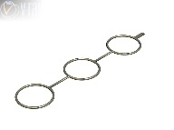 | 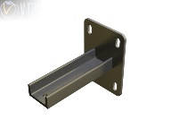 | 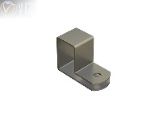
51LİK KOPENTİ | 51’LİK side hanger | 168’LİK Side hanger | Pipe hanger | Internal diagonal
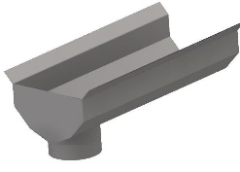 | 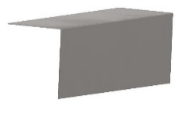 | 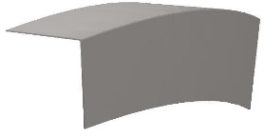
Bleed gutter | Side ridge | Ridge

Bolt and bolt nuts

All the fasteners used in the greenhouse shall be 8.8 steel bolts and bolt nut.

M10 sheer connector
M8X50 6 corners bolt
M8X30 TAMPON
bolt

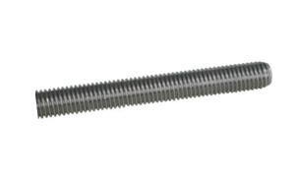
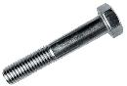
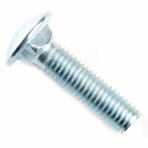

Hexagonal galvanized bolt | M12X100
Galvanized stud | M10X130
Hexagon galvanized bolt | M8X50
Hexagon galvanized bolt | M8X40
Hexagon galvanized bolt | M8X30
Galvanized bolt with camber head | M8X30
Galvanized Smart Screw | 3,9X13
Galvanized Smart Screw | 4,2x25
Galvanized bolt nut | M12
Galvanized bolt nut | M10
Galvanized boltsomun | M8

POLYCARBON AND GREENHOUSE NYLON

The side of the greenhouse will be covered with 8 mm double-walled transparent polycarbonate. Greenhouse tops 350 micron, min. It will be coated with UV-IREVA doped Plastic Greenhouse Nylon which is 36 months resistant.
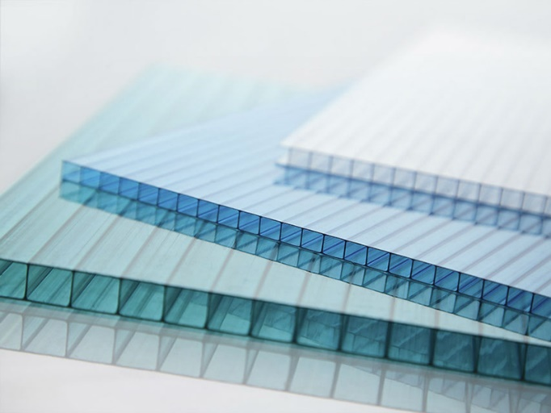

Greenhouse Steel Construction and closure with polycarbonate material, including side windows, over the greenhouse shading mechanisms and 85% shading will be with tulle (net).

Heat and share curtains

Closed transparent polyester blend woven curtains shall be used as heat curtains. Curtain system geared motor will be opened and closed automatically with rope winding shaft assemblies.

Working area: at 5.00 m intervals (along the greenhouse).
Heat protection: 45-60%
UV: 6
Working system: Pull-wire
Motors: Suitable for automation with at least 400 minton safety swicht reducer
Shaft pipes: Ø 60 mm Galvanized steel pipe
Suspended fishing line: 2 mm Polyester, transparent
Curtain drag pipes: 19 mm

• All greenhouses, ventilation windows, control systems and cable trays and panels carrying power cables shall comply with the standards.
• The interior of the greenhouse will be illuminated at least with 2x36 waterproof luminaire u-type fluorescent bulbs at 5-meter intervals to provide sufficient light at night.
• Waterproof luminaires shall be waterproof, dust-proof, shall be in starter sockets and shall be delivered together with their bulbs. Installation of the luminaires in the greenhouse, connection of the luminaires to the power line, etc. to be carried out by the contractor.
• Rail automatic top spray irrigation system will be made.
• There will be 1 door in the greenhouse. Entrance hallway head 3 meters panning sideways
• 2 circulation fans with a capacity of 7000 m³ / hour will be used in the greenhouse. Circulation fans are made of sheet metal and will be completely painted with oven.
• For greenhouse heating system, up to 200 m2 area, it is recommended to install air heaters that operate on three types of fuel (natural gas, liquefied gas and diesel fuel) which can heat up to -18 degrees to +18 degrees

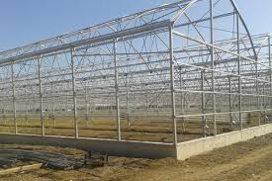

GREENHOUSE CONCRETE WORKS

Greenhouse interior and exterior concrete works will be done by the contractor.

WARRANTY CONDITIONS

The technical problems that may occur in the manufacturing parts of the greenhouse subject to this technical specification and any damage caused by external extreme weather conditions (rain, snow, wind, frost etc.) of the greenhouse shall be under the guarantee of the contractor for minimum 2 years.

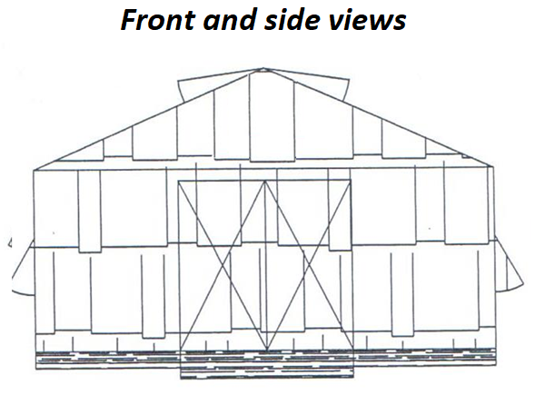

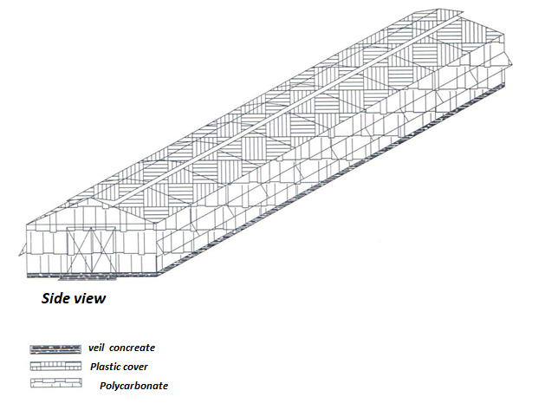

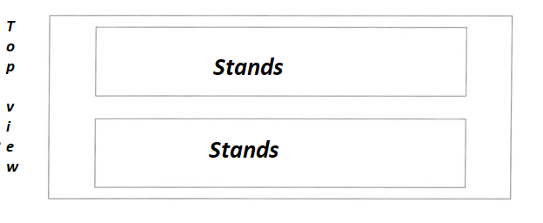

- Technical Specifications for Sheltered Area

The works will be done at the Absheron Nursery. The contractor will provide all the materials required for the execution of this project and a complete list of them is given below. The materials specified in this list is going to be additionally provided by the contracting authority, if they are found to be inadequate during application.

However, the contractor without any additional charge shall meet machinery, vehicles, tools and equipment that may be necessary for the installation and assembly of the facility. Other consumables may be needed will be covered by the contractor.

List of Materials to be supplied

# | NAME AND SHORT DESCRIPTION OF THE GOODS, ITEM | UNIT | AMOUNT
1 | Galvanized Strut Pole (60*3.6 mm) (Assembly included) | Piece | 36
2 | Galvanized Pole (60*3.6 mm) (Perforated) (Assembly included) | Piece | 36
3 | Galvanized Pole (60*3.6 mm) (Assembly included) | Piece | 54
4 | Flange (6 holes) (Galvanized) (Assembly included) | Piece | 90
5 | Galvanized Wire Rope (6 mm) (Assembly included) | Meter | 4000
6 | Canopy (55% green color) (3 * 22.5 m) (Including assembly) | Piece | 75
7 | Screw and salmon with stud (14-16 cm) (Including assembly) | Piece | 80
8 | Terminal Block (8 mm) (galvanized) (incl. Mounting) | Piece | 500
9 | Galvanized Tensioning Apparatus (16 pieces) (Including assembly) | Piece | 300
10 | Ready Mixed Concrete (C 20-25) (Including casting to molds) | m3 | 100
11 | Preparation of 40x40 Plywood mold by installing screws | meter | 465
12 | Rebar (Min 10 mm) (including turning into stirrups and placing them in the mold) | Kg | 1200
13 | Rebar (8) (including stirrup and insertion into mold) | Kg | 600
14 | Carbine (Control hook) (Galvanized 7 cm) (Including assembly) | Piece | 11000
15 | Pumice (25cm * 33cm * 24cm) (including assembly) | Piece | 11000
16 | Floor Cover (Jut Black) (incl. Mounting) | m2 | 7000
17 | Hard core (7-20 mm) (Including 7 cm height spreading on an area of ​​5225 square meters | Ton | 650
18 | Gravel (7-20 mm) | Ton | 350
19 | 30x50 mm gravel (including filling in V channels) | Ton | 140
20 | U bout (60 in) (Assembly included) | Piece | 150
21 | Galvanized terminal block (5mm) (Assembly included) | Piece | 250
22 | Galvanized Wire Rope (4 mm) (Assembly included) | Meter | 2000
23 | Plastic Velcro (15 cm) (Assembly included) | Piece | 5000
24 | Plastic Velcro (40 cm) (Assembly included) | Piece | 1000
25 | 120 liters / hour 2-3 bar reverse mini sprink set (Assembly included) | Piece | 570
26 | 120 liters / hour 2-3 bar reverse mini sprink set (Assembly included) | Piece | 180
27 | 20” Straight coil pipe (including mounting to molds and rope) | Meter | 2600
28 | 90 coils straight pipe (including assembly) | Meter | 230
29 | Valve of 20 (including installation) | Piece | 50
30 | Elbow of 20 (Including assembly) | Piece | 50
31 | Blind plug of 20 (including installation) | Piece | 50
32 | 90 Coupling (Including assembly) | Piece | 5
33 | 90 Coupling Elbow (Including Assembly) | Piece | 5
34 | 90 '' Coupling Blind plug (including installation) | Piece | 3
35 | 90 '' Coupling T Pipe (Assembly included) | Piece | 1
36 | 90-piece socket necklace - half finger (incl. Mounting) | Piece | 40
37 | 20 'Male Coupling (Assembly included) | Piece | 120
38 | 8 cm deep 50 cm wide foundation excavation | Meter | 465
39 | 20 cm deep, mouth width 20 cm V excavation | Meter | 3515
40 | 50 cm deep 50 cm wide channel opening and laying 90mm pipes, giving 20 outputs, installation and covering | Meter | 205

The layout of the molds will be in the area where the molds will be placed, 8 cm deep and 50 cm wide, in the excavated area. During the assembly of the molds with screws, 20-coil pipe (600 meters) will be used to provide screw input and output. In accordance with the attached project, it will be formed in 4 rows perpendicular to the south-north line, approximately 23 m apart, rectangular on the east and west sides. 40 * 40 2.50m in the molds, manufactured by the contractor, stirrups ten-tier reinforcement will be placed in 20 * 20 cm stirrup, (between the stirrups, reinforcement will be 40 cm.) Mold will be installed. Wedges shall be placed under the stirrup to prevent the stirrups from coming into contact with the soil. The molds installed will be fixed and they will be prevented from slipping during concrete pouring. Molds (plywood and Gijon studs) shall be supplied by the administration.

As shown in the example, galvanized poles at 3.15 m intervals shall be aligned and arranged in 4 rows with 23 m spacing as shown in the mold. 30 * 30 cm trough shall be opened on the inner parts of the rows of both heads and the legs of the galvanized strut shall be placed. The holes in the galvanized pipe will be covered with 2 holes on the upper part of the strut and will be joined by using bolts and nuts. Stanchions and poles shall be fixed after they have been sent, and after they are inspected by the inspection staff they are in the same order, the pits and the ready-mixed concrete shall be poured into the mold at the same time. The posts shall be upright and at the same height and height. During the pouring of concrete, the contractor shall carry out the necessary technical works and take the necessary measures in order to ensure that the molds and poles and the strut are not distorted in the miter and direction, there are no concrete gaps on the edge of the molds and the leveling of the concrete is smooth.

Wait at least 24 hours for the molds to be removed. Concrete will be watered according to weather conditions. When the molds are finished, they will be stacked properly. At the end, the stitches of the poles shall be as shown below.
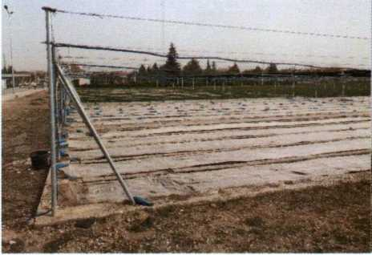

As it is shown in the example of Subannex 1, 37 drainage channels (V-shaped, top width is 20 cm and depth is 20 cm) shall be opened parallel to the concrete indicated by a and b and coarse gravel shall be filled into these channels (creek pebbles or crushed stone shall not be accepted). After that, the ground cover will be laid on the whole floor, and 5 cm high 7-20 mm stone chips will be laid and leveled. The leveling will be completed in the north-south direction, 120 cm spaced rows will be formed, double rows 25*33*24 cm briquettes and 37 walls will be built.
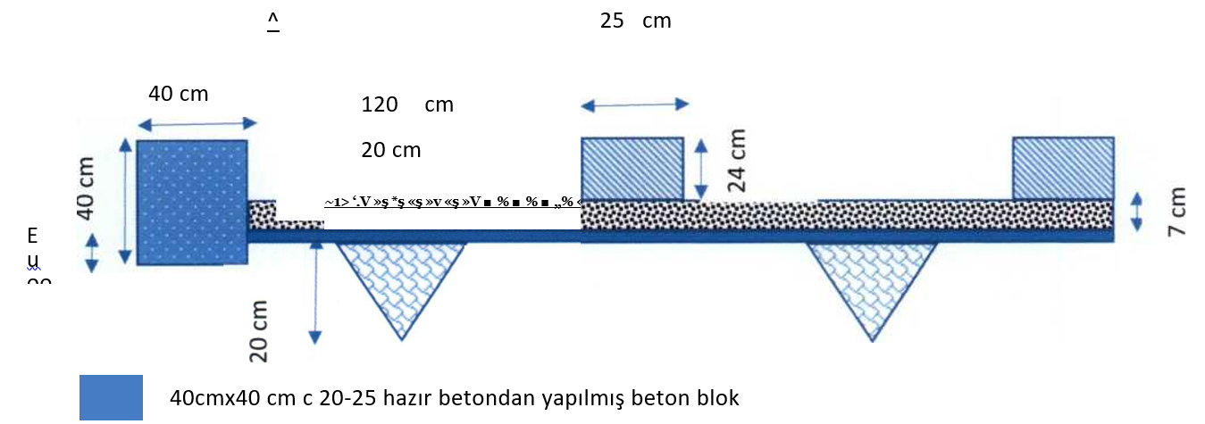

Shallow Top Irrigation Covered Sapling Production Parcel Preparation Work Related to the Parcel Section Cross Section

25cm * 40cm * 24cm dimensions and minimum 300 dose concrete briquette

7 cm high 7-20 mm stone chips layer

20 cm deep mouth 20 cm V channel inside 3-5 cm stone (gravel) will be filled

Cover

There will be 18 poles in a row (90 poles in 5 rows). Flanges must be fixed to galvanized poles by welding or screws to prevent them from being mounted on all poles of the flanges whose shape is shown in the technical specification in order to prevent them coming out in windy weather. The flanges shall be mounted on the tops of the galvanized poles and the steel ropes shall be tensioned to the flange by means of the tensioning apparatus to be connected to the tensioner and the steel rope clamp. The steel rope will be stretched in this way. Sewn shaded tulle will be attached to the steel ropes from the sides and head sections using carbine hooks.

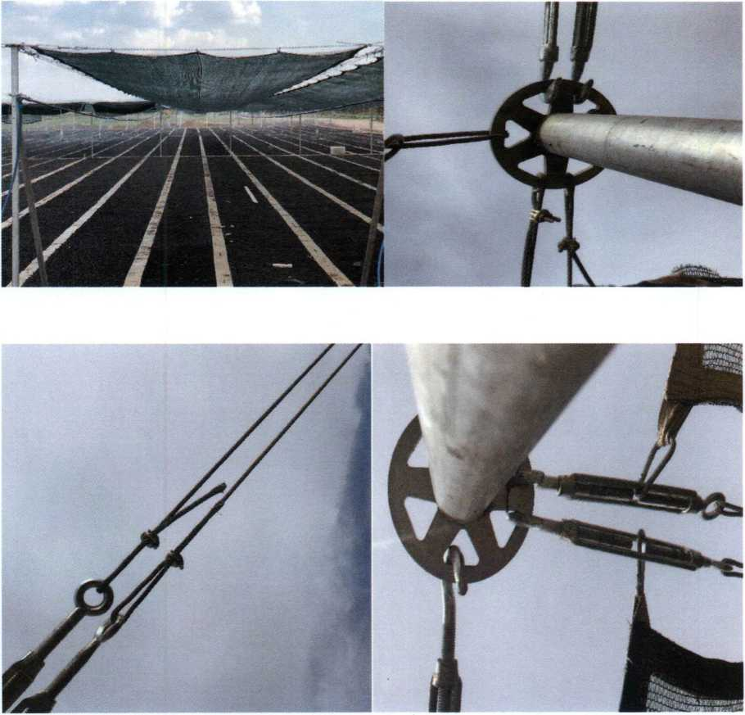

Sewing Carabiner Hooks to Shades: Carabiners will be sewn to shades so that shades are stretched between ropes mounted and stretched with tensioning apparatus and clamps to poles which are erected and flange mounted at 3.15 meter intervals. In the places mounted on the canopies, the edges including the canopy edges along the sides and side edges shall be planted from sunlight, rain, frost and temperature material in order to prevent tearing and tearing. Planting will be made in such a way that the carbine and the shade can be removed and installed instead of the junction. The carabiners will be attached to the shades with a distance of 50 cm as shown below:

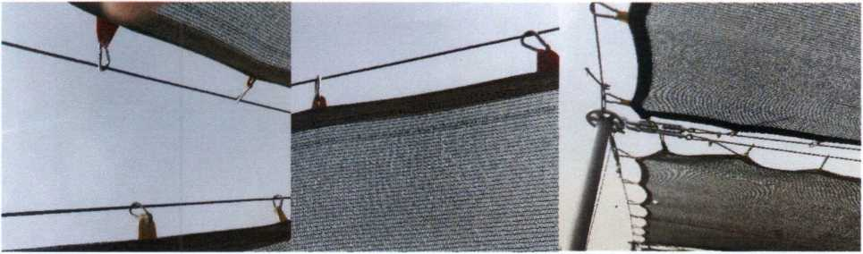

Since mini sprinkling will do the irrigation of the parcel from the top, 20 pipes will be mounted to the galvanized pipes with the help of steel ropes. The poles where the steel ropes are stretched are the poles that are planted for the shading facility and are available in the seedling production parcel. 90's coils will be drawn to the sides of the parcel by using elbows and T. In the parcel, as described above at intervals of 3.15 m, the bollards will be connected to the 60 poles produced by the administration, the steel ropes will be connected to the tensionings by the clamp, the ropes will be tensioned by installing the U bolts. As seen in the example of Subannex 3, 90-coiled pipes drawn to the parcel edge will be drilled from the poles and 20 pipes will be attached to 90 pipes with the apparatus (The related gasket apparatus will be provided by the contractor). 20 pipes connected to 90's pipe will be used 20' elbows at the exit through the channel to the poles. Metal poles will be attached to the rope with Velcro. Valves of 20 shall be installed per each row, tightened with clamp, and the elbows shall be connected and clamped with the same way. The same process shall be carried out on opposite sides of the parcel so that the 92.40 meter parcel will be divided in two. Irrigation will be done in a way that will split the parcel in two. After the elbow, it shall be connected to steel rope by means of Velcro at maximum 30 cm intervals until the middle of the parcel. 120 liters / hour, 2-3 bar reverse mini siprink set with 300 cm spacing will be mounted to the 20 pipes connected to the ropes by drilling. Apparatus for drilling both 90 and 20 pipes shall be provided by the contractor. In the event that the system does not operate at appropriate pressure and homogeneous distribution, the contractor is obliged to make the system operational and to make the whole parcel irrigated in such a way that it does not leave any spaces. They cannot claim any rights against these works. After all the works are completed and trial irrigation is done, upon the approval of the administration, the channel where 90 pipes are passed will be closed and leveled regularly. The contractor without any charge shall cover other consumables that are not in the list that may be needed during manufacturing. This will be taken into consideration when submitting bids by the tenderer.

Details of the needed equipment/materials

- Galvinized pillars

60*3,6 Gavinized pipes

60 * 3,6 (Outer diameter thickness shall be 59-61 mm. Wall thickness shall be 3.6 mm, the linear meter shall weigh at least 5 kg). Galvanized pipe (3 meters long, 8 cm 30 cm long to fix the galvanized pipes, as shown in the figure will be welded with anchor iron). The required holes shall be drilled from the mounting points on the 36 poles to be fitted with struts (90 Piece). (Shown in Figure-1 below).

60*3,6 Galvinized pipes (buttress)

60 * 3,6 (Outer diameter thickness shall be 59-61 mm. Wall thickness shall be 3.6 mm, the linear meter shall weigh at least 5 kg). Galvanized pipe (3 meters long). In order to serve as an outrigger to the existing standing galvanized fixed galvanized pipes, one side shall be bent to give an angle of 156 degrees and the related screw places shall be drilled or cut from 20 cm and welded to an angle of 156 degrees. In order to prevent corrosion at the welds, it must be immersed in galvanized in welded condition. Non-galvanized outriggers that may cause corrosion will not be accepted. In addition, two 8 mm screw holes will be drilled for fixing to vertical galvanized pipes. The upper sides will be covered with a plastic cover to prevent water from entering the pipes (36 pieces) (shown in Figure 2 below).

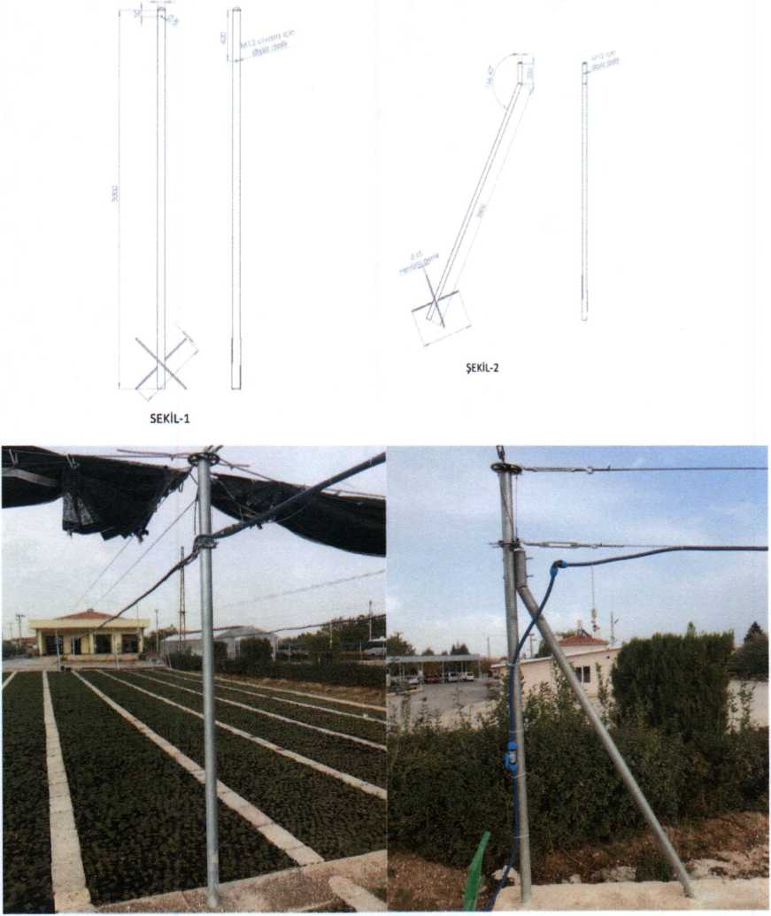

- Flange

The flange shall have 6 holes. Under 8 mm thickness, 30 cm length of 48 pipe shall be dipped galvanized in welded condition (as shown in the figure below). If these flanges are welded to poles made of galvanized pipe as described in paragraph 1, 30 cm 48 pipe shall not be required and shall be dipped in welded condition in order to prevent corrosion from welding places. Flanges that have not been submerged will not be accepted.
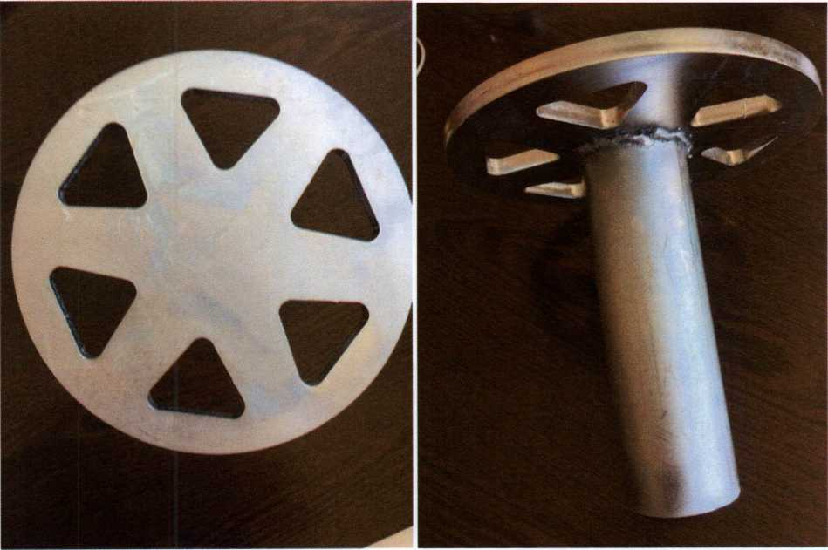

- 6*12 GALVANİZED HEMP CORED STEEL ROPE

6*12 Galvanized hemp cored steel rope (6 mm) (galvanized steel ropes will play a role of ray for thr shade system). (4000 metre) (as shown in below picture).

- Linker (8 mm Galvanized)

A type linkers of 8 mm, galvanized, wil be used to link ropes (500 pieces) (As shown in below picture).
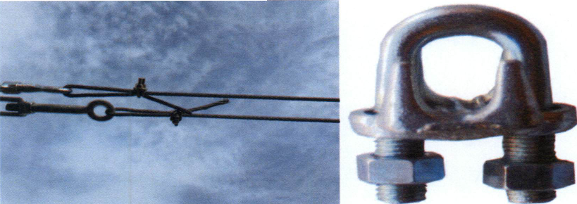

- Stretching Unit

Galvinized strecching unit, M16 (as shon in below picture)
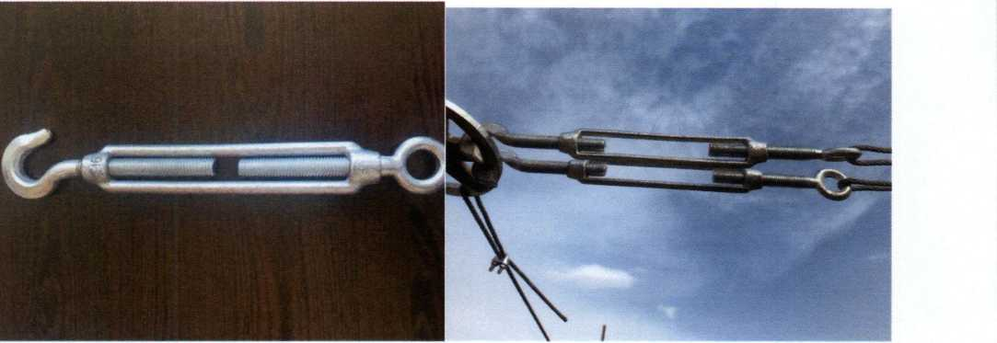

- Canopy (shade) (%55 Green)

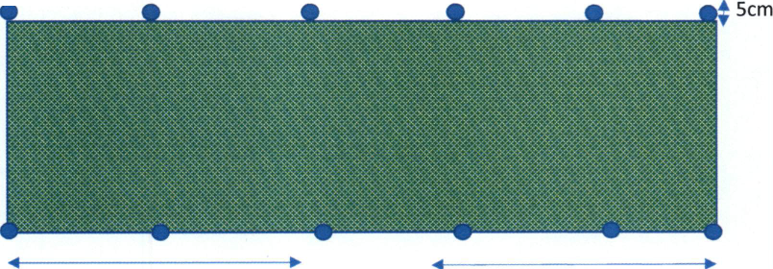
The shade (55%) meter should be at least 40 grams. It will be 3 meters wide and 23 meters tall. A roving frame with a width of 5 cm shall be erected with a frame on all sides. After roving, the length should be 23 meters and the width should be 3 meters. Apparatus shall be erected from the tent in order to provide tensioning at 30 cm intervals and to move on steel ropes (Subannex 2).

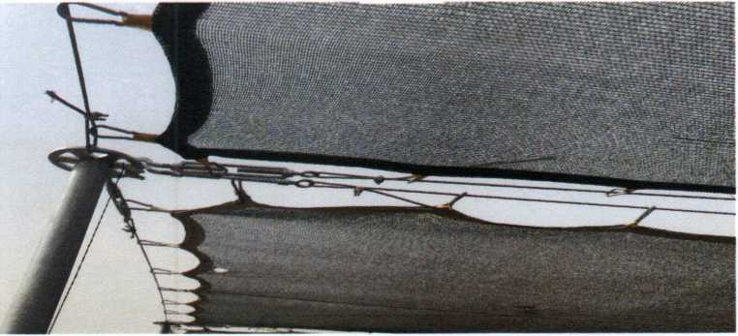

- Stud Screw and Bolt Nut

3 * 8 thick 160 mm stud bolts and nuts (80 pieces). It will be used in the mounting of the pillar with the buttress and the installation is included.

- Concreate (C20)

Ready-mixed concrete (C20 dose). Casting and leveling into the mold and at the bottom of the strut is included (100 m3).

- Assembling 40x2,50 Plywood Molds

The 40x2.50 plywood molds will be joined using a sheer connector and a 20-inch coil pipe. 8x50 cm foundation excavation will be placed on the foundation. Total amount of mold to be made is 465 meters.

- 10’ rebar

10’ rebar to be used in stirrups in concrete and to be turned into stirrups, including binding wire and mounting and placed in molds (1200 Kg).

- 8” rebar

8 rebar. 20 * 20 * 20 * 20 cm in size with a distance of 10 cm around 10 cm irons will be ironed for the mold and will be connected with binding wire, bending, binding and placement of the molds are included. (600 kg).

- Carabiner

Carbine (Commando hook) will be used to connect the shades to the galvanized ropes (11,000 pieces). Shade and rope installation included.

- Pumice briqquetes (25x33x24 cm)

It shall be manufactured from kiln and baked. The related briquettes will be arranged in 120 cm intervals and turned into seedlings pan (11,000 pieces).

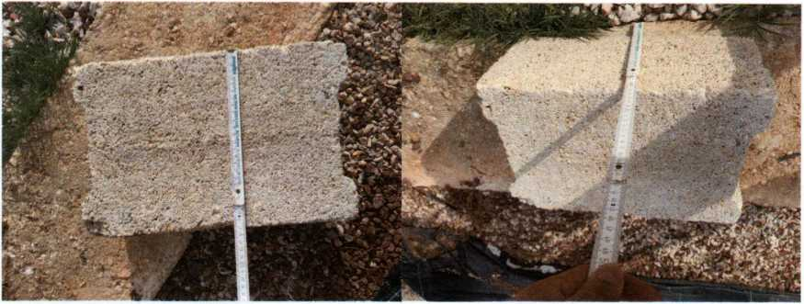

- Floor Cover (Black)

· It shall be manufactured with 4.20 m wide black and at least 100 gr/m² standards with UV additive to withstand long-term sunlight.
· 4.20 m wide edges will be sewn.
· The color will be black or close to black tones. Delivery will be made after the color selection is confirmed by the administration.
· It will be 100% polypropylene.
· The cut edges will be hot cut.
· Tolerance in the dimensions of the base cover width of 4.20 m shall be accepted as ± 5.
· The base cover should be able to absorb the above water and should not pass the weeds in the soil to the top of the seedlings.
· The floor cover will be laid on the whole floor after the V channel is excavated, the gravel is filled, and the concrete and iron works of the parcel are completed. In order to avoid opening in the ground during the paving process, the pavement will be continued by overlapping 10 cm above each other at the joints of the base covers. During the laying process, the shrinkage of the base cover will not be allowed, and the tearing of the base cover will be taken into consideration during the crushed laying process.
· The amount of floor cover to be purchased and laid on the floor is 7000 m2

- Stone chips (Gravel) (7-20 mm)

Gravel may be crushed stone or natural stone. Since the purpose of laying the gravel on the base cover is to provide drainage, there should not be any material less than 7 mm in the gravel to prevent water drainage. Gravel should be washed. Gravel V channel is excavated and filled with gravel, concrete and iron works are completed, and the ground cover is laid, then it will be laid on the ground cover to cover the whole area with a thickness of 7 cm and its leveling will be done. It will be laid on an area of 650 tons and will be stacked to 350 tons.

- 30x50 mm Gravel

V-shaped drainage channels with 20 cm mouth width and 20 cm depth will be excavated and then 30x50 mm creek or crushed stone gravel will be filled (140 tons).

- U BOLT (of 60)

U-bolts shall be 60 and galvanized. U-bolts are required for the installation of the steel ropes that will hold the irrigation pipes to the poles and the strength should be 50 meters long, with the sprinkles attached at 3 meters intervals and the pipes carrying the water filled 20 pipes with minimum 20-bar pressure and they should be fixed without turning. U-bolts which are found not to have the desired properties during the trial will not be accepted.
Rope will be towed between all available poles for 18 rows. These ropes will be mounted to the poles with the help of U bolt (150 U Bolt of 60).

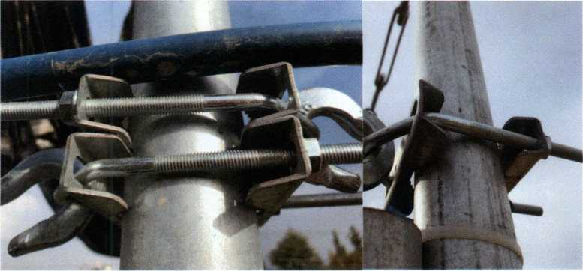

- Galvinized linkers (5 mm)

There will be a need for linkers to strecht the ropes. It will be of 5 mm and 250 pieces.
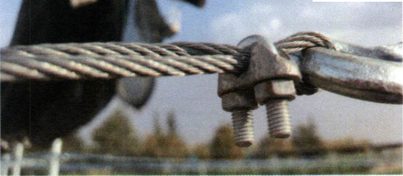

- GALVANİZED HEMP CORED STEEL ROPE (4 mm)

4 mm hemp cored steel ropes will carry irrigation pipes. The bolts shall be mounted and tensioned by using the U-bolt tensioning apparatus and the terminal block from the height indicated by the administration.

- Plastic clamps (15 cm)

15 cm plastic Velcro are necessary for the installation of 20 cm irrigation pipe to the rope and will be installed to connect the rope and the pipe with a distance of 30 cm (5000 pieces).
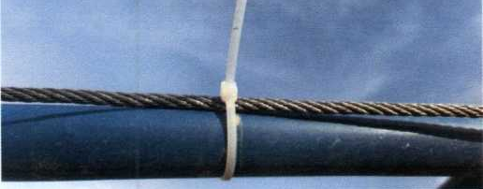
- Plastic clamps (40 cm)

Plastic clamps of 40 cm are required for the installation of 20 pipes and 20 valves on 60 galvanized poles and 20 coil pipes shall be fixed to the poles by means of clamps with 30 cm spacing (1000 40 cm plastic clamps).

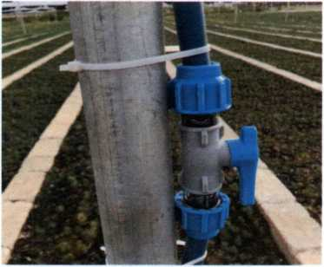

- 120 Litr/hour 2-3 Bar Reverse Mini Sprink Set

Mini sprinklers shall be in a set and shall have a minimum extension of 30 cm. Sprinklers shall be assembled to 20 coiled pipes drawn from the height indicated by the administration with the help of ropes as described above at 3 meter intervals. The apparatus for drilling the pipes of 20 shall be provided by the contractor. The contractor shall take the necessary measures to prevent water leakage of the sprinklers from the installation site. Because in case of water leakage, the job will not be accepted and the contractor will be asked to eliminate this problem. The amount of sprinkling installed by the contractor in the parcel is 650 pieces and 350 pieces will be delivered to the warehouse of the administration.

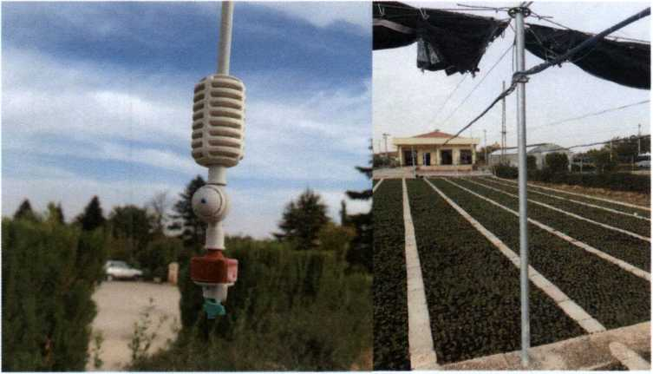

- 20 '' Straight Coil Pipe, 20 '' Valve, 20 '' Elbow, 20 '' Blind Plug and 20 'Male Coupling

It is the pipe to be used to distribute the water required for irrigation of the parcel from the main pipe of 90. Drill through the 90-part pipes at the beginning of the parcel with the apparatus to be provided by the contractor, 20-set socket with pendant and male cable will be mounted along the pole with plastic Velcro to the pole will be fixed to the location of the 20-point valves will be installed. The 4-steel wire rope described above will be fixed to the rope with 15 cm plastic fasteners by attaching 20 bends. The process will continue along the 47-meter line and the end will be fitted with a 20-foot cap. The same procedure shall be carried out in both directions (north and south) of the parcel. The amount of coil pipe to be used for irrigation is 2,000 meters.

During the assembly of the same coil pipe molds, the gigons are cut by 40 cm and passed through the prepared 20-coil pipe so that the gigons holding the molds do not remain in the concrete. The amount of hunk pipe to be used in the molds is 600 meters. Valves of 20 ', 50' of elbow 50, blind plug of 20 'and male coupling of 20 are 120 pieces.

- 90; Straight Coil Pipe, Coupling, Blind Plug, Coupling Elbow and T Pipe, Plug Socket Pendant

At the beginning of the parcel (South) 50x50 excavated from the valve into the canal with coupling, elbow, T will be laid with the help of the South and north of the parcel with the help of socket necklace will be mounted on 20-pipe. The construction of the work is seen in Subannex 3. 90 coiled pipe to be used is 230 meters, 90 coils; coupling 5 pcs, coupling elbow 5 pcs, coupling blind plug 3 pcs, coupling T 1 pcs, socket necklace 40 pcs.

- 8 cm Depth 50 cm Wide Foundation Excavation

It will be dug to the place where the concrete molds will be placed. The length to be excavated is 465 meters (Subannex 1).

- Opening of V Drainage Channel with 20 cm Depth and Mouth Width 20 cm

A V-shaped drainage channel will be opened at 120 cm intervals, the first one being 60 cm of the parcel's edge, the material coming out of the channel will be taken out of the parcel, and 30x50 mm gravel will be filled into this channel. The relevant study is seen above in the ground section.

- Opening of 50x50 cm Dimensions Installation of 90 Pipes Installation of 20 Pipes and Covering the Channel

It is the process of closing and leveling by taking the necessary measures to prevent harmful and cutting materials from coming into the pipe without damaging the joints and joints of the pipes following the inspection and approval by the inspection staff and the approval of whether there is any leakage.

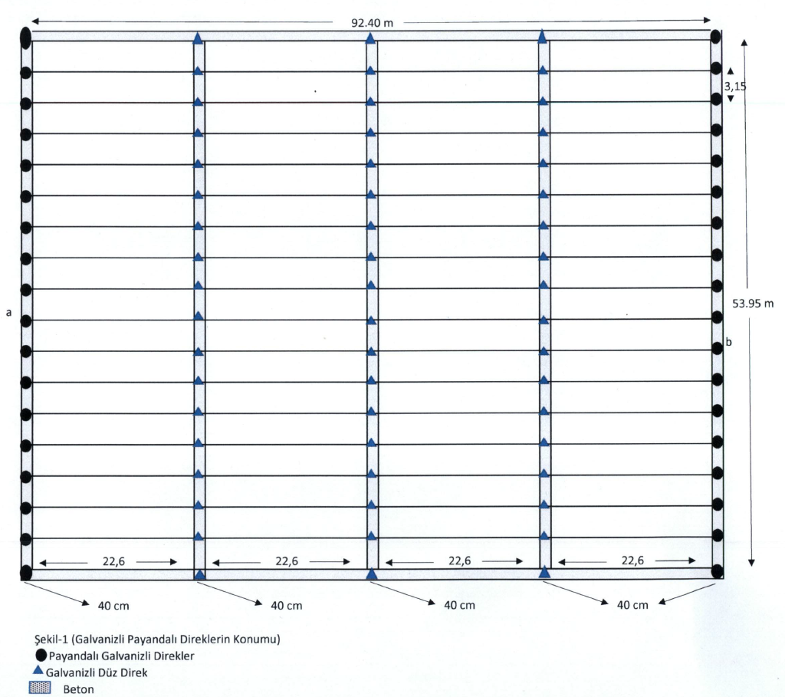
Subannex 1. Tava betonlarının ve direklerin konumu
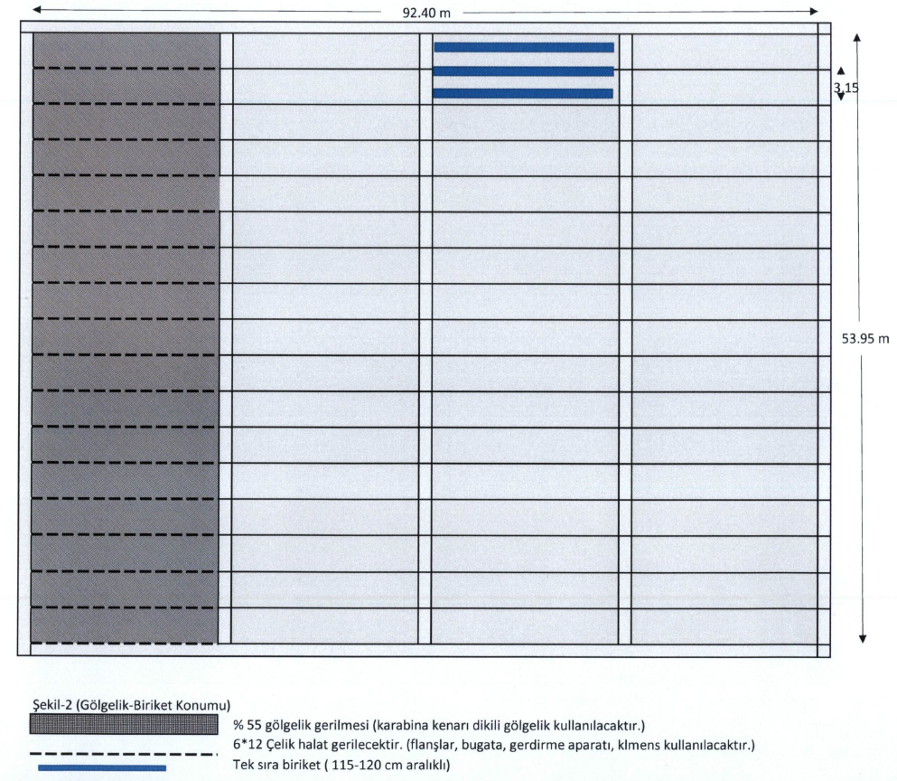
Subannex 2. Location of canopy and briquettes

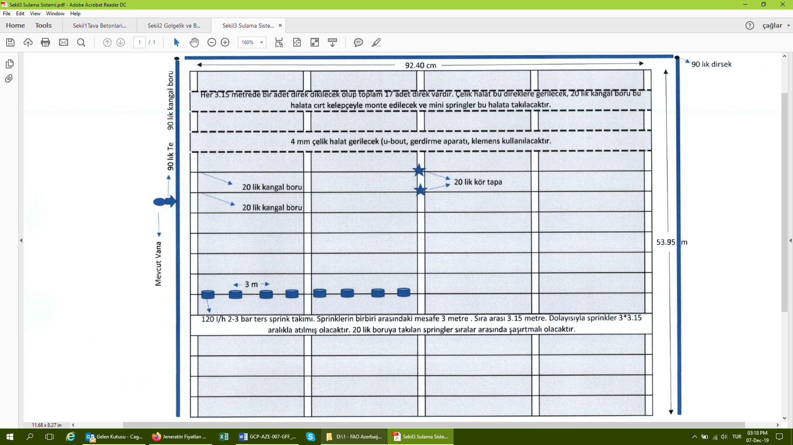
Subannex 3. Irrigation system
- Technical Specifications for Generator

Minimum Requirements:
Type of generator: petrol (AI 92)
Number of stages: 3 (380/220 volts)
Engine volume: 277 cubic meters. cm
Fuel processing: 2.1 l/s
Volume: 7.3 l
Type of generator: synchronous
Protection class of generator: IP23
Engine power: at least 6 HP or 5-10 kVA
Type of compressor: air compressor or any other is acceptable

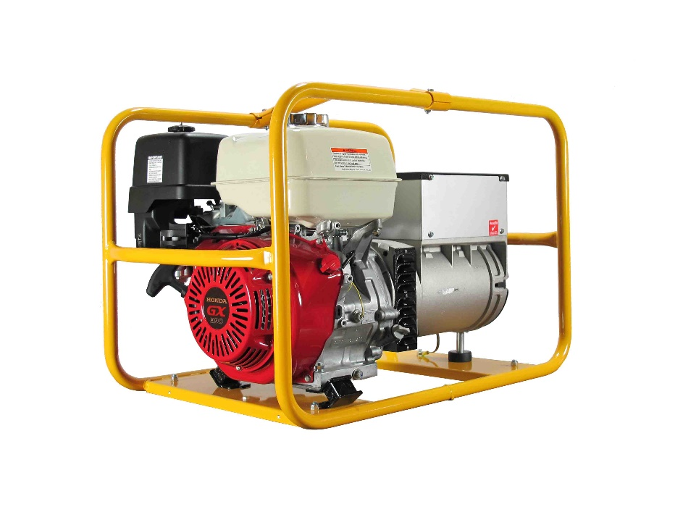

- Tech Specs for Irrigation, Drainage and Pumping Systems

Item | Name and technical specifications | Unit of measurement | Quantity
1 | PE Pipe 110 PN6 | m | 630
2 | Latched pipe 90 PN6 | m | 312
3 | Latched pipe 75 PN6 | m | 1735
4 | Latched pipe 63 PN6 | m | 1735
5 | Sprayer | pieces | 347
6 | Sprayer vintil | pieces | 347
7 | Switch | pieces | 347
8 | Spinrikler system (detailed tech specs provided below) | unit | 1
9 | Pumping system (detailed tech specs provided below) | unit | 1
10 | Filtration system | unit | 1
11 | Fertilization system | unit | 1
 | TOTAL

Drainage Canal | Depth: 2 m  Widht: 2 m  Length: 650 m  Open canal, no construction is needed, excavator will directly open the canal | 2,600m³

Dry containers
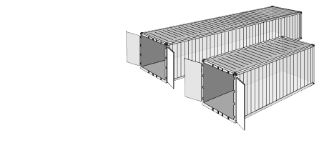
Dry containers are manufactured from either aluminium or steel. Aluminium dry containers have a slightly larger payload than steel, and steel dry containers have a slightly larger internal cube.
Will be used to fit in pump station to pump irrigation water to modernized area of the Nursery.
Tare weight | Payload capacity | Cubic capacity
2,300 kg | 25,000 kg | 33.2 m³
5,071.5 lbs | 55,126.9 lbs | 1,172 cu ft
Internal width | Internal height | Door opening width
2.35 m | 2.39 m | 2.34 m
7.7 ft | 7.9 ft | 7.7 ft

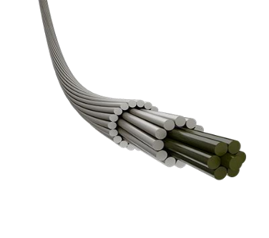
Electricity lines
- Total length: 1250 m
- Maximum authorized temperature of operation: +90 °C
- Service life: min 25 years
- Warranty period from the date of putting into operation: 4 years
- Cross-section area: 50/8.0 mm2
- Breaking strength, N (min): 17112
- Estimated weight of a wire, kg/km: 194.0
- Maximum conductor resistance at a temperature 20 °С (max): 0.5951

Pump specifications

- Liquid type: clean water
- Uses: domestic, civil, industrial
- Applications: water supply systems
- Performance Range: Flow rate up to 450 l/min (27,0 m³/h) Head up to 112 m
- Application Limit: Temperature of the liquid from -10 °C to +90 °C, Ambient Temperature -10 °C to +40 °C
- Manometric suction lift up to 7 m
- Max. working pressure 10 bar (6 bar for 2CP25/130N)

Spinrikler system

Designed for cooling and humidifying greenhouses or for irrigating over rooting tables.

- Static mister, 3 different flow rates: 5.5, 7.5, 14.0 l/h and a plugged nozzle
- Nominal flow rates at 4.0 bar pressure.
- Pressure range 3.0 - 5.0 bar.
- Recommended filtration : 130 micron / 120 mesh.
- Filtration method is to be selected based on the kind and concentration of the dirt particles existing in the water.
- Wherever sand exceeding 2 ppm exists in the water, a Hydro-cyclone filter is to be installed before the main filter.
- When sand/ silt/ clay solids exceed 100 ppm
- Inlet connector: Press fit
6. Bare-rooted Conifer and Broadleaved Seedling Production Area

- In total, 350,000 conifer seedlings and 300,000 deciduous seedlings in Absheron Nursery.

- Total number of parcels: 2 parcels

- Total area of 1 parcel: 8.100 m2

- Seedlings will be produced on beds. Soil preparation is followed by soil tear up by disk harrow or rotavator to establish seedling production beds

- The surface of the seedling production beds should be smooth as much as possible, and the direction of the beds should be straight.

- The width of the beds is 120 cm and the distance between the beds is 40 cm. Beds should be established 10 cm higher than the ground level to allow drainage. Beds should be established in the fall season, if possible. Fall and winter rain will lower the pH and lime levels.

- To sow seed on the beds, 7 lines should be established for conifers or 5 lines should be established for deciduous (broadleaved) species.

- the distance between the lines is 15-17 cm for conifers, 20-24 cm for deciduous species.

- Lines can be established with sowing machine (drill) or roller. The depth and the direction of the lines should be the same. Seeds can be sowed by hands or sowing machine

- Bare-rooted seedling production parcels will be established in two ha to produce conifer and deciduous species.

- Sprinkler irrigation system will be used for watering purposes

- Container Seedling Production Area

Container seedling production can be done in two ways. First, one is to sow seeds directly to the containers. The second one is to produce seedlings is viols in greenhouse and replace the seedlings to containers or seedling production beds. Two or three seeds should be sowed to container maximum.

Polyethylene bags will be used as containers. The maximum size of these bags is 14-15*23cm. Three container seedling production parcels will be established in Absheron Nursery to produce around 500,000 container seedlings. Sprinkler irrigation will be used for watering purposes.

- Total number of parcels: 3 parcels
- Total area of 1 parcel: 4.500 m2
- The base of the container seedling production beds must have 1-2% slope,
- 20 cm depth drainage canals must be built in the middle of each bed. Drainage canals will be filled with cobble.
- Two-layered (two-fold) polyethylene cover must be spread on the ground to cover the drainage canals and container seedling production beds.
- Width of the container seedling production beds will be 120 cm; the distance between the beds that are called bed roads will be 20 cm.
- Bed roads will be paved with briquettes.
- Asphalt stone chips (No.4) will be spread on the polyethylene cover. Thickness of the stone chips will be 6-8 cm.
- Polyethylene bags or container cases (Type: Spencer) will be placed on the stone chips.

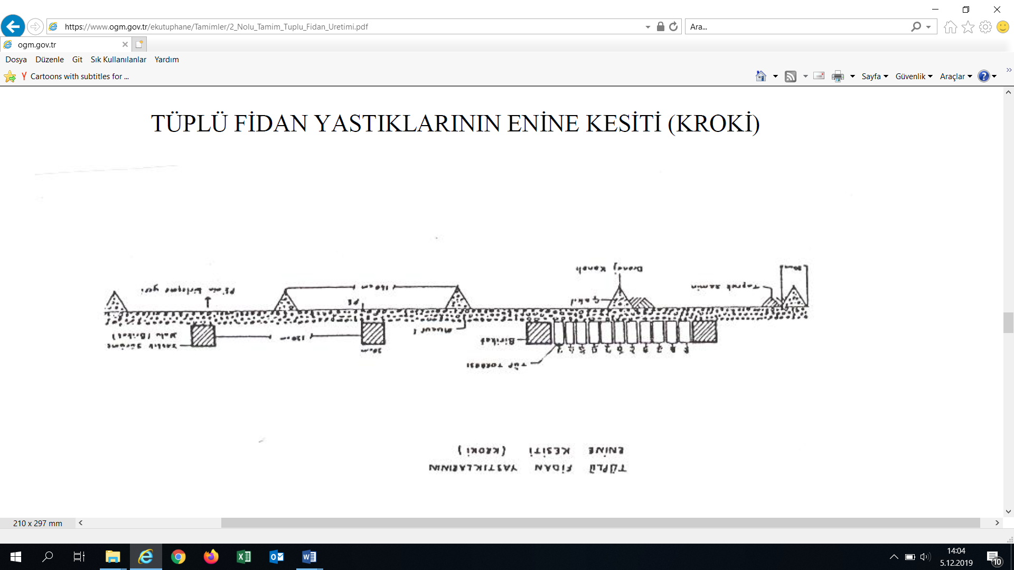

Figure 10. Cross section of the container seedling production beds

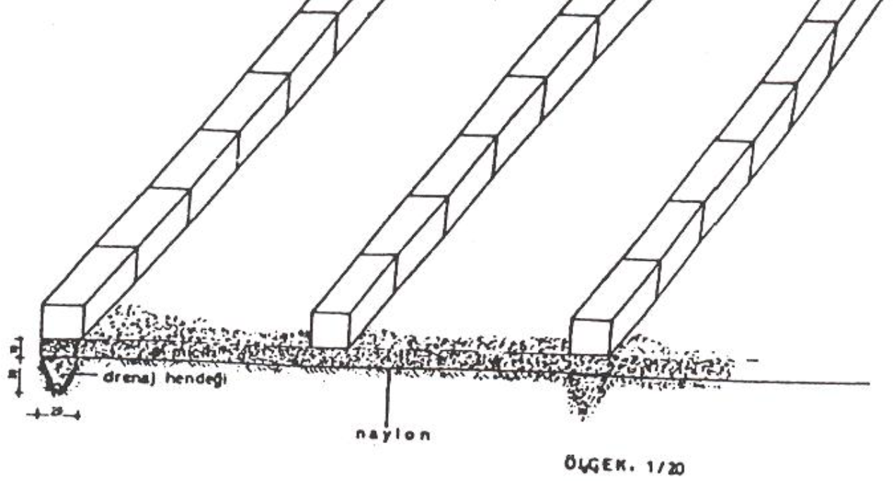
Figure 11. Cross section of the container seedling production beds

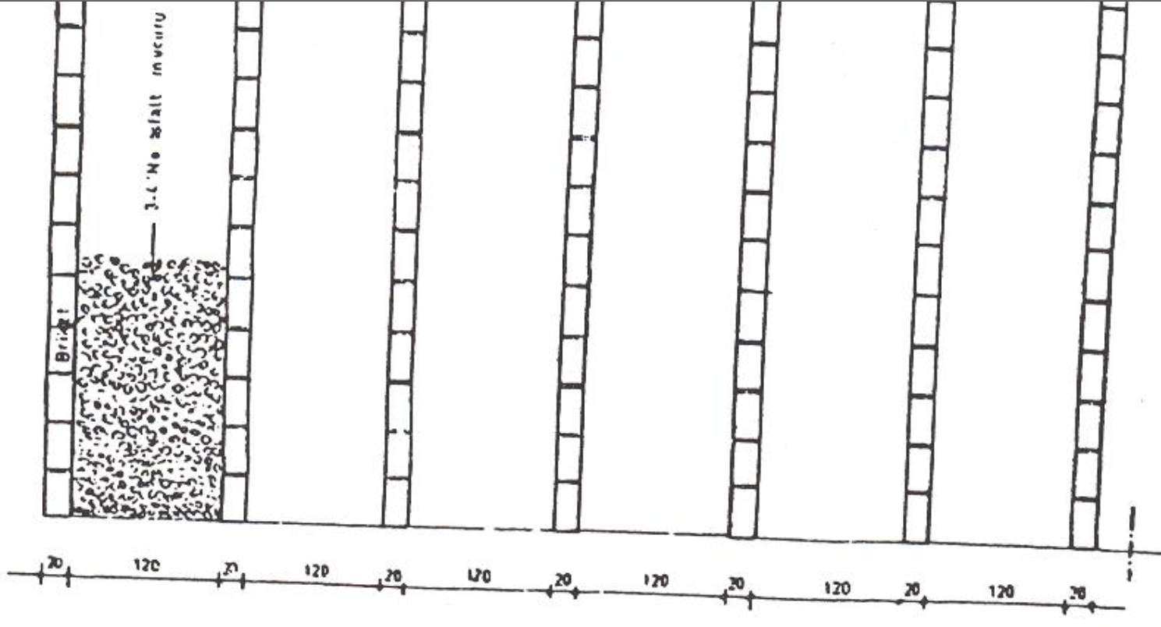
Figure 12. Cross section of the container seedling production beds
- Open Shelter Area Renovation

WORK TO BE DONE | QUANTITY | SIZE
Repair of th shelter
gravel | 640,00 | M2
Fixing grid to be used for concreate works | 500,00 | M2
Laying down and levelling the concrete - 10cm | 1117,00 | M2
Plastering works | 682,00 | M2
Painting of facede | 290,00 | M2
Dissmantling of older rooftop | 972,00 | M2
Front and side mounting with box profile | 1000,00 | M2
Construction of stainless/colored rooftop and side parts | 1000,00 | M2
Materials to be used | QUANTITY | SIZE
SAND | 22,00 | M3
CEMENT 400 BRAND | 7500,00 | KQ
Gravel | 32,00 | M3
Grid to use for concreate works | 175,00 | ƏDƏD
CONCRETE B-25 | 65,00 | M3
BURNED WIRE | 10,00 | KQ
PRIMER PAINT | 450,00 | KQ
EMULSION FACADE | 350,00 | KQ
INTERNAL EMULSION | 350,00 | KQ
BOARD (5X10) | 10,00 | M3
BOX PROFILE (IRON) | 400,00 | M
PVC WINDOWS (12 pieces, 1 m X 1 m) | 12,00 | M2
PVC DOOR (2 pieces, 2 m x 1 m) | 4,00 | M2
ELECTRODE | 21,00 | KQ
Spare part for lagonda | 10,00 | ƏDƏD
STAINLESS COLORED METAL ROOFTOP | 1000,00 | M2
NAILs | 30 | Kg
 |  | Total

- Water Reservoir

WORK TO BE DONE | QUANTITY | SIZE
MAIN REPAIR of reservoir (depth - 2.30, width - 5.30, length - 9.50)
Provision with RESIN (BITUM ISOLATION) | 50,00 | M2
Provision with 2 LAYERS RUBEROİD | 44,59 | M2
METAL CARCASS AND CONCRETE WORKS | 39,15 | M2
INTERNAL PLASTER works | 40 | M2
WATER Based ISOLATION (ISOLATEKS) | 105,88 | M2
EXTERNAL side plastering works | 25 | M2
Materials to be used | QUANTITY | SIZE
SAND | 2,50 | M3
CEMENT 400 BRAND | 700 | Kg
RESIN (BİTUM İSOLATION) | 50,00 | Kg
RUBEROİD 12 -piece ( roll) | 108 | M2
FIXTURE – 12 mm | 800 | pm
WATER Based ISOLATION (ISOLATEKS) | 125,00 | Kg
 |  | Total

100m³ Water reservoir Scheme

2.30
9.50

11. Fencing

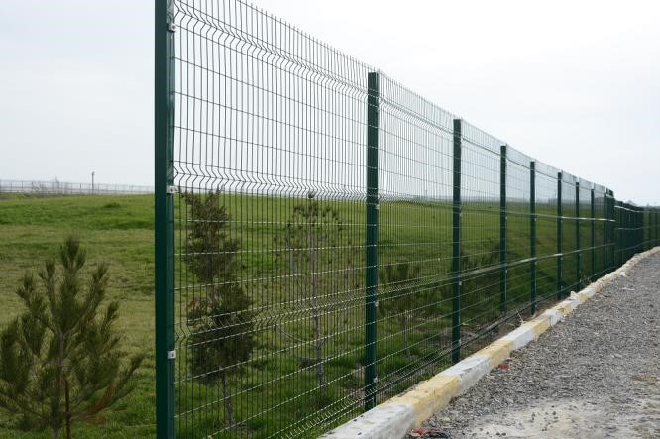
Technical specifications:

- Total distance to be fenced – 600 m
- Wire fences at 2.5 m of width and 2.4 -2.5 m of height
- Corrosion resistant, galvanized wires used
- Wire fences are fastened to each other through clips and pillars.
- Wire diametr 4-7 mm
- Number of steel pillars -240
- Pillar height – 2.5 m with sizes of 80 mmx60mm/3 mm
- Electro powder painted, preferable in green color
- Zinc coating 60-80 m2

12. Modern Machinery and Equipment

Item | Technical Specifications | Unit of Measurement
Tractor with bucket | Minimum Reguirements:  95 hp  4x4  Distance between wheels max. 140 cm, adjustable  Pto-driven, 540/1000 revolutions per minute  Hydraulic to assemble equipment from front and rear  Warranty: Min 2 years | 1 tractor with bucket
Tipper trailer | Minimum Reguirements:  Min capacity is 3.5 tons  2 wheeler tipper trailer  Distance between wheels max. 130 cm, | 1 tipper trailer
  Light weight: | 1140 kg
  Loading capacity: | 3500 kg
  Cargo space: | 3,9 m³
  Area of loading: | 5,3 m²
  Total length/most/height: | 4200/2050/1700 mm
  Sidewall heigth: | 450x285 mm
  Ground/Wall thickness: | 2 mm
  Platform height: | 950 mm
  Wheel track: | 1600 mm
  Suspension: | Spring leaf
  Tyres: | 10/75 - 15,3
  Max. speed | 20 km
  Roll-over System: | Back
  Telescopic cylinders: | 1/3
  Oil demand: | 8 Liters
  Operating pressure: | 160 PS
  Min tractor power need: | 50 hp / 37 kW
  Brake system: | Hiydraulic
Plow | Minimum Reguirements:  Three socket eccentric plow  Plow length: 16"  Weight: 420 kg  Work width: 1200mm  Underbeam clearance: 750 mm  Required tractor: 75hp-90 hp | 1 plow
Rotovator | Minimum Reguirements:  Proccessing width: 130 cm  Tillage depth: 10-15 cm  Proccessing speed: 2000 m/hour  Average work efficiency: 2.6 decare/hour  Daily work efficiency: 20.8 decare/8 hours  Pulled by 24-36 hp tractor | 1 rotavator
Cultivator | Minimum Reguirements:  Proccessing width: 150 cm  Proccessing depth: 5-15 cm  Proccessing speed: 3000 m/hour  Average work efficiency: 4.5 decare/hour  Daily work efficiency: 36 decare/8 hours  Pulled by 24-36 hp tractor | 1 cultivator
Bucket with loader | Minimum Reguirements:  Loads 0.2-0.25 m³ material each time  Average work efficiency: 13 m³/hour  Daily work efficiency: 104 m³/8 hours  Pulled by 24-36 hp tractor | 1 bucket with loader
Root cutting knife | Minimum Reguirements:  Proccessing width: 140 cm  Tillage depth: 20-25 cm  Proccessing speed: 2600 m/hour  Average work efficiency: 5.2 decare/hour  Daily work efficiency: 41.6 decare/8 hours  Pulled by 36-55 hp tractor or crawler tractor | 1 root cutting knife
Drill (Sowing machine) | Minimum Reguirements:  Proccessing width: 120 cm  Seed depth: 1-5 cm  Seed sowing speed: 1700 m/hour  Average seed sowing efficiency: 2 decare/hour  Daily work efficiency: 16 decare/8 hours  Pulled by 24 hp tractor | 1 drill
Hoeing machine | Minimum Reguirements:  Proccessing width: 240 cm  Tillage depth: 5-10 cm  Proccessing speed: 3500 m/hour  Average work efficiency: 8 decare/hour  Daily work efficiency: 64 decare/8 hours  Pulled by 24 hp tractor | 1 hoeing machine
Bed machine | Minimum Reguirements:  Proccessing width: 160 cm,  Tillage depth: 10-15 cm  Proccessing speed: 2000 m/hour  Average work efficiency: 3.2 decare/hour  Daily work efficiency: 25.6 decare/8 hours  Pulled by 24 hp tractor | 1 bed machine
Seed Roller | Minimum Reguirements:  Proccessing width: 120 cm  Seed depth: 1.5 cm  Seed sowing speed: 3000 m/hour  Average work efficiency: 3.6 decare/hour  Daily work efficiency: 28.8 decare/8 hours  Pulled by 24 hp tractor or manually | 1 seed roller
Clamping roller | Minimum Reguirements:  Proccessing width: 120 cm  Proccessing speed: 4000 m/hour  Average work efficiency: 4.8 decare/hour  Daily work efficiency: 38.4 decare/8 hours  Pulled by tractor or manually | 1 clamping roller
Motorized sieve | Minimum Reguirements:  Average work efficiency: 2.4 m³/hour  Daily work efficiency: 19.2 m³/8 hours  Reuires 10 hp engine | 1 moterized sieve
Strimmer (weedeater) | Minimum Reguirements:  Total cylinder capacity: 28 cm³  Total cylinder capacity: 1.7 cu.inch  Power output: 0.7 kW | 2 strimmers
Knapsack sprayer |  | 2 knapsack sprayers
  Minimum Reguirements:  Engine | Single cylinder, 2-cycle engine
  Max. Power | 1.2 hp - 0.9 kW
  Cylinder volume | 37,7 cc
  Disinfection Storage | 25 Liters
  Jet throw | 8 m
  Max. jet throw | 10 m
  Handling system | Corded
  Fuel | Gasoline and two-stroke-cycle gasoline engine lubricant  Mixing ration: 25:1
  Bunker capacity | 0.6 Liter
  Weight | 10,4 kg
  Spray pipe and pipe length | 1.2 m
  Drug type | Liquid
  Track width Min/Max | 405/330/640 mm
Measuring tape (5 m) | Minimum Reguirements:  Tape Length: 5 m  Tape Width: 19 mm dull polymer-coated blade  Material: Stainless steel  Easy Read, Bold printing, comfortable for people with a weak eyesight  Ensures Class II Accuracy at 20ºC when subjected to a tension of 50 Newton  Corrosion-resistant Tru-zero end hook for accurate measurements  Standar locking system and pause system  Strap Belt Buckle  Hanging rope | 8 measuring tapes

13. Consumables

Item | Tecnical Specifications | Unit
Staking cord | Minimum Reguirements:  Diameter (mm): 2.2-3.5  Runnage (mtr/Kg): 185-75  Breaking Strength (Kgf): 220-475 | 10 Bobbin
Manure (NPK Complex 15-15-15) | Follow FAO Fertilizer Specifications  - Moisture content by weight: maximum 1.5%  - Total nitrogen content by weight (on dry basis): minimum 15%  - Neutral ammonium citrate soluble phosphate (as P₂O₅) content by weight: minimum 15%  - Water soluble phosphate (as P₂O₅) content by weight: minimum 12%  - Water soluble potash (as K₂O) content by weight: minimum 15%  - Particle size: Not less than 90% of the material shall pass through 4 mm IS sieve and be retained on 1 mm IS sieve. Not more than 5% shall be below 1 mm size  - Packing: Packed in 50 kg (dry) capacity woven polypropylene bags with polyethylene inner lining. 4% empty bags to be supplied at no extra cost  - Each bag to guarantee minimum product weight (net) as specified on the bag  - Marking: Product name, active ingredient(s), net and gross weight, address of final destination. | 5 tons
Viols for 45 seedlings | Minimum Reguirements:  Type: 45 (5x9)  Gram: 120 gr  Most: 30 cm  Lenght: 50 cm  Height: 6.5 cm  Bottom: 5 cm  Top: 6.5 cm | 2,500 viols
Growing medium/Potting soil | Minimum Reguirements:  PH: 5.0-6.0  N: 100-200 mg/liter  P₂O₅: 120-220 mg/liter  K₂O: 140-240 mg/liter  Mg: 60-100 mg/liter  100 liter closed packages | 200 m³
Liquid Fungicide | Minimum Reguirements:  Active ingredient  250g/l Difenoconazole  Formulation  Emulsifiable concentrate (EC)  WHO classification: III  Rates of application  Apply at 0.5 litres/ha | 100 Liters
Granulated sulphur | Minimum Reguirements:  Colour: Yellow-grey  Sulphur content, (%) min: 99.95  Chemical impurity: 0.05  Humidity, (%) max: 0.5  Class of granule 0,5mm – 6,3 mm, min.: 90%  Granule culture 0,5mm and class of granule 6,3 mm - 10mm, max: 10% | 0.5 tons
Nylon package | Minimum Reguirements:  Material: Polyethelene  Black-colored and scentless  Impermeable,  Size: 40x60cm, 30x50cm, 22x14cm  Thichness: 140 micron for single layer | 1,000 kg
Plactic wastebin for Office | Minimum Reguirements:  Capacity: 50-100 liters  Material: Plastic  Shape: Cylindrical | 20 watebins
Hoe (anchor) | Minimum Reguirements:  Min 3 mm steel galvanize  Wooden Handle lenght: 45 cm | 50 hoes
Spade | Minimum Reguirements:  2 mm steel galvanize | 10 spades
Shovel | Minimum Reguirements:  1.7 mm steel galvanize | 10 spades
Spade and Shovel Handle | Minimum Reguirements:  Material: Steel  Lenght: 150 cm  Diameter: 34-42 mm | 20 handles
Pickax | Minimum Reguirements:  50 cm pickax  Wooden Handle lenght: 95 cm | 10 pickaxes
Harrow | Minimum Reguirements:  Steel 18 tooth harrow  5 mm steel galvanize  385 mm width  Diameter 29 mm  Wooden Handle: 140 cm | 10 harrows

Tech Specifications for Items to be provided through In-Kind Activities by MENR

- List of Office Furniture and Renovation of Existing Facilities (Will be contributed by MENR)

Item | Unit
Office (25 m²) | 1 room
Office (15 m²) | 3 rooms
Office (25 m²) | 1 room
Kitchen (10 m²) | 1 room
Archive (15 m²) including shelf cupboard | 1 room
Store (15 m²) including shelf cupboard | 1 room
WC (4 m²) | 2 WCs
Meeting desk | 1 desk
Chairs for meeting desk | 6 chairs
Desk | 14 desks
Seats | 14 desks
Chairs | 30 chairs
Cabinets | 10 cabinets
Electricity wiring | 1 electric wiring
Central heating combi boiler | 1 combi boiler
Curtains | 10 curtains
Renovation of existing shelter area for storing machinery, vehicles and items (With sections, shutter and shelves) | 1 shelter area
Store and associated rooms | 3 stores and rooms
Workers facility (2 WC, 2 Bathrooms, 2 Changing rooms (5mx7m) including cabinets for 25 women and 10 men, cafeteria (5mx10m), dining tables for 35 workers and 35 chairs | 1 workers facility

- Office Building Renovation (MENR)

WORK TO BE DONE | QUANTITY | SIZE
Renovation of the main office building
DISMANTLE OF PVC Ceiling Panel | 424,40 | M2
DİSMANTLE OF LAMİNATE | 110,00 | M2
Providing internal plaster | 314,40 | M2
General works on water and combi system (necessary items are listed below)
Plaster and emulsion | 314,40 | M2
PVC Ceiling Panel CONSTRUCTION | 116,00 | M2
DRYWALL CONSTRUCTION | 110,00 | M2
LAMINATE CONSTRUCTION | 110,00 | M2
Ceiling molding | 110,00 | M
Baseboard | 104,00 | M
Window belts | 8,00 | M
Repair of the outside surface and emulsion | 152,32 | M2
Repair of entrance stairs | 6,75 | M2
CONSTRUCTION OF DOORMAT | 200,00 | M2
DISMANTILE OF DOORMAT | 200,00 | M2
Materials to be used | QUANTITY | SIZE
SAND | 8,00 | M3
CEMENT 400 BRAND | 3000,00 | KQ
MATA | 125,00 | KQ
BİNDER | 10,00 | KQ
PRIMER PAINT | 75,00 | KQ
Emulsion Facade | 100,00 | KQ
INTERNAL EMULSION | 200,00 | KQ
ELECTRICAL WIRE 2x2,5 | 400,00 | M
ELECTRICAL WIRE 2x4,0 | 400,00 | M
ELECTRICAL PIPE | 200,00 | M
ELECTRIC DISTRIBUTIVE CASE (GENERAL) | 1,00 | PIECES
ELECTRIC DISTRIBUTIVE CASE (INTERNAL) | 1,00 | PIECES
ELECTRIC KEYS (AUTOMATIC) | 12,00 | PIECES
LED LIGHTS | 24,00 | PIECES
PLASTIC WATER PIPES f-25 | 100,00 | M
PIPE ISOLATION | 100,00 | M
WATER HEATER | 1,00 | PIECES
GAS REGULATOR | 1,00 | PIECES
ELECTRIC REGULATOR | 1,00 | PIECES
THERMAL RADIATOR (5x1,20m, 2x2,00m, 1x0,80m) | 10,80 | M
Vintil (combi) | 1,00 | PIECES
Necessary spare parts for water pipes
LAMINATE PARKET | 115,00 | M2
Plintus | 110,00 | M
Necessary spare parts for plaster pines | 115,00 | M2
Plaster works (1 surface) | 600,00 | KQ
Plaster works (2 surface) | 360,00 | KQ
Galvanized steel corners | 30,00 | PIECES
IRON DOOR (FOR ENTRANCE) | 1,00 | PIECES
Plastic window belts | 10,00 | M
Necessary spare parts for water system
LAMBIR (Including PROFILE AND OTHER ACCESSORIES) | 120,00 | M2
PVC WINDOW (1,75x1,40-5əd,1,75x1,00-1piece,) | 10,50 | M2
PVC DOOR (2 PIECE) | 4,00 | M2
TRANSPORTATION COSTS
Stone stares (aglay) | 6,75 | M2

Office Building Scheme

5.000
TOP FACADE M 1 : 100

3.000

2.600

0.800 ₊ 0.000

-0.600
4
1

11600

1
5.000
A
C

SIDE FACADE M1:100

3.000

₊ 0.000

-0.600

10400

- Guard Office Renovation (Will be in-kind contribution of MENR)

WORK TO BE DONE | QUANTITY | SIZE
Renovatoin of the guard office
Disassembling laminate | 26,50 | M2
Plaster works | 50,00 | M2
Provision of general electricity (necessary materials are shown below)
Plaster (alchi) and coloring | 94,20 | M2
Lambrine | 26,50 | M2
Plaster pans | 26,50 | M2
Laminate | 26,50 | M2
Laminate corners | 22,60 | M
Plintus | 22,60 | M
Window belts | 8,00 | M
Renovation of the outside surface of the building | 67,80 | M2
Installation of doormats | 100,00 | M2
Dismatching doormats | 100,00 | M2
Materials to be used | QUANTITY | SIZE
SAND | 3,00 | M3
CEMENT 400 BRAND | 1200,00 | KQ
MATA | 50,00 | KQ
BİNDER | 5,00 | KQ
PRIMER PAINT | 50,00 | KQ
EMULSİON FACADE | 75,00 | KQ
INTERNAL EMULSION | 100,00 | KQ
ELECTRICAL WIRE 2x2,5 | 200,00 | M
ELECTRICAL WIRE 2x4,0 | 200,00 | M
ELECTRICAL PIPE | 100,00 | M
ELEKTRİC DISTRUBUTIVE CASE (INTERNAL) | 1,00 | PIECES
ELECTRIC KEYS (AUTOMATIC) | 6,00 | PIECES
LED LIGHTS | 8,00 | PIECES
LAMİNAT PARKET | 30,00 | M2
PLASTİK PLİNTUS | 30,00 | M
Plaster pans | 30,00 | M2
Plastering (surface) | 210,00 | KQ
Plastering (second surface) | 240,00 | KQ
Galvinized steel corners | 15,00 | PIECES
IRON Door (for Entry) 2,75x0,90 | 1,00 | PIECES
Window belts | 6,00 | M
LAMBİRİNE (PROFILE AND OTHER ACCESSORIES) | 30,00 | M2
PVC WINDOW (1.75x1.25-2piece,1.75x1.00 - 3 piece.) | 9,63 | M2
PVC DOOR (2,00x0,90 - 2 piece) | 3,60 | M2
TRANSPORTATION COSTS
RENTING OF IRON DOORMAT (MONTHLY) | 100,00 | M2
 |  | Sum
 |  | Total

Scheme of the checkpoint (guard building)

FACADE 2:1

3950

2500 3150

1000

0.00 +0.0

-0.30
1
2

5. Manure storage place

Manure Facility | 3mx6mx3m  U Shape Concrete | 2 facilities | 1,500 | 3,000

Deputy Head of Department, Afforestation Department, General Directorate of Forestry, Turkey, ahmetyalvac@ogm.gov.tr, +905052168511
National Consultant, Food and Agriculture Organization of the United Nations (FAO), caglar.bassullu@fao.org, +905058914267
National consultant, iragim_forest@mail.ru

